**Theta Gamma Thoughts**

Theta Gamma, Chapter # 195, Area V, Corpus Christi

The Delta Kappa Gamma Society International, Texas State Organization

Volume # 47 Issue # 04 January 2015

Mission Statement: The Delta Kappa Gamma Society International promotes professional and personal growth of women educators and excellence in education.

Leading Women Educators Impacting Education Worldwide

Editor: Carol Walker [walkerbc64@msn.com](mailto:walkerbc64@msn.com)

**President’s Message**

Dear Sisters,

Hello to you all for the first time in 2015. I am hoping a happy, healthy New Year for each and every one of us.

Today at school, my Co-teacher was asking the children about New Year’s Resolutions. I loved listening to the funny the ideas that came from 7 year old children. Tonight, it made me reflect on our group and positive changes we can make in our world this year. I have been so excited with our new ideas and also the “ice breaker” getting to know each other, at each meeting. It seems to me all of us are enjoying these fun tasks. Thanks Kimberly for getting that together for us. Each meeting so far has been so inspiring and motivating to be a member of Theta Gamma. I have heard myself say more than once to a member who might not have been able to make a meeting….. “Oh, you should have been there… it was a great meeting”.

With you support and guidance, I have made it half way thru my first year of being your president. It has not been hard at all. It keeps me on my toes and honestly, it has been a challenge that I have really enjoyed. I thank you all for your smiling, encouraging faces at each meeting.

Now on to the rest of this year. We have lots of projects on the fire... The Fill a Purse project, sewing pillow cases for Shriner’s Hospital, Painting at Crazy Picasso, and bringing books in to be sent to another country. Wow… we better get busy.

I look forward to helping some of you sew this month. I am going to make it very easy for you and all you have to do is follow a line. You will want to go home and make pillow cases for everyone in your family. Yes, I have done that! That is also our annual Chili supper... My favorite eating meeting! Our weather sure has been just right for this activity.

Take care and enjoy the “Chili” weather,

Shannon

**Next Meeting Information:**

**January 22,** 2015 5:15 p.m.

We will have our Annual Chili Super at Calallen Baptist Church.

[Calallen Baptist Church Map Link](http://calallenbaptist.org/how-to-find-us)

**For Our Pillowcase Project**

Bring ¾ yard of one fabric and ¼ yard of a coordinating fabric for the trim to the meeting.

If you have one yard alone, that is also fine.

Bring your sewing machine if it is portable.

If you sew, pins and scissors would be helpful.

Shannon will be bringing in extra fabrics and three machines. If you have any questions call Shannon at 387-5740.

Also, bring books suitable for the elementary school library in the Philippines named after Neva Gentry’s daughter-in-law.

**Minutes of the**

**December Meeting**

12/4/2014

The meeting was called to order at 5:40 by President Shannon Clubb at the home of Libby McGee. Members present were: Cynthia Besosa, Kimberly Brumley, Shannon Clubb, Kimberly Craig, Laura Day, Margaret DeVille,

Ann Falkner, Neva Gentry, Sylvia Gonzalez, Norma Janice, Libby McGee, Donna Rodenberg, Angela Steagall, Beverly Tackett, and Debbie VanZandt. A quorum was confirmed.

Shannon opened the meeting with a funny story about a dream that she had about not being prepared for a meeting and having Cynthia Besosa teach us all calligraphy. Cynthia confirmed that she has, in fact, taken a calligraphy class.

Kimberly Craig facilitated a “Find Someone Who” Christmas-themed game as an ice breaker. She also passed out a sheet with 25 daily Random Acts of Kindness and challenged members to participate.

The October minutes were approved as printed in the last newsletter.

Because Linda Uballe was sick and unable to attend the meeting, Norma Janice presented the Treasurer’s Report. The beginning balance was $2107.41. Income received from dues, Pace, and the basket drawing amounted to $684.36. Disbursements to State and International and to Delta Psi for initiation expenses totaled $1871.55. The final balance on hand is $920.22.

There was no President’s Report except that Shannon announced that she made hot chocolate on a stick for everyone at the meeting.

Kimberly Craig, in the absence of Brandey Addison, called for votes on the items which were tabled from the last meeting due to the lack of a quorum.

1. Crazy Picasso fundraiser – held to defray some of the costs of any service projects that we do. A vote was taken and the motion passed.
2. Fill-a-Purse to benefit the Women’s Shelter – Brandey or Kimberly will contact the Women’s Shelter to be sure that they don’t have new requests. It was suggested that we purchase multiples of the same item and fill the purses by assembly line during a meeting. A vote was taken and the motion to continue with this project passed.
3. Books for an elementary school library in the Philippines – Neva Gentry’s daughter-in-law has a connection with an elementary school in the Philippines which did not have a library. They are requesting new or gently used books to put in the library. It was suggested that people who bring books to the meeting might get an extra ticket for the basket drawing. No vote was taken.
4. Books for Driscoll – Vote was tabled until team can check with Driscoll to find out if there is a need for this project.
5. Teen Bookfest by the Bay – no club monetary support is necessary, although individual donations can be given to Debbie VanZandt at any meeting. A motion to provide volunteer support for the Bookfest on February 28, 2015 was approved.

Kimberly Brumley presented the program based on the book ***Lean In*** by Sheryl Sandberg. She tied the book’s theme to both Christmas decorations and the purposes of Delta Kappa Gamma. For our rededication to DKG, we learned that members must **lean in** by 1) participating in meetings, projects, and activities of their chapter, area, state, and international organizations; 2) sharing interests, talents, and professional expertise; 3) seeking out opportunities to grow personally and professionally and supporting others in their growth; 4) becoming involved in chapter life by attending meetings, participating in activities, using voice and vote in chapter business, taking risks, and taking advantage of opportunities; and 5) accepting leadership roles in the safe, supportive environment of the Society.

Shannon announced that ASTEF supports Texas women educators with scholarships and grants and suggested that members look into what they offer.

The Pride and Prize Pop Quiz question for this month was “When is the Alpha State Convention?” The correct answer is June 25-27, 2015. The winning entry was Norma Janice. She won a mini Poinsettia.

There was no basket drawing this month, and the Pace amount was not counted at the meeting. The meeting adjourned at 7 p.m. for a Christmas social.

The next meeting will be the Annual Retiree’s Chili Supper at Calallen Baptist Church (13505 IH 37 Access) on January 22, 2015. Members are encouraged to attend and bring fabric, sewing machines, and other supplies to sew pillowcases for children at Shriner’s Hospital.

**Seen at the**

**December Meeting**

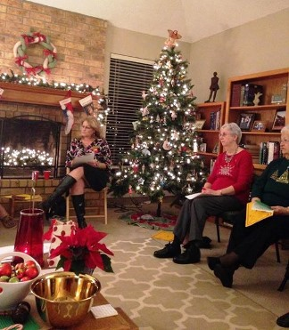**Photo by Kimberly Craig**

Left to Right: Laura Day, Norma Janice, and Neva Gentry concentrating during the meeting in the beautifully decorated for Christmas home of out hostess, Libby McGee

**Future Meetings**

**February 19**, 2015 5:15 p.m.

Nolan’s Restaurant, on Airline Road

Program: The Healthy Heart

[Nolan’s on Airline Map Link](http://www.bing.com/maps/default.aspx?q=Nolan%27s+Restaurant+Corpus+Christi+TX&mkt=en&FORM=HDRSC4)

**March 7,** 2015 11:00 AM

**Joint Chapters Annual Spring Luncheon** Beta XI will host at First Baptist Church

**April 23,** 2015 5:15 p.m.

Miller High School Library

Program: “Bucket List”

[Miller High School](https://maps.google.com/maps?bav=on.2,or.r_qf.&bvm=bv.74649129,d.b2U,pv.xjs.s.en_US.ZIOukfQmgko.O&biw=1272&bih=600&dpr=1&wrapid=tljp141019811564310&um=1&ie=UTF-8&fb=1&gl=us&sll=27.795214,-97.422646&sspn=0.0291566,0.0439465&cid=2451827330239612031&q=roy+miller+high+school&sa=X&ei=buoNVJ_YOoaL8QGOloGgDw&ved=0CIUBEPwSMAo)

**May 21,**  2015 5:00 p.m.

Sugarbakers Restaurant on Santa Fe

Our recruitment grant scholarship and May Blyth grant to a member will be awarded at our **Founder’s Day/Birthday celebration**.

[Sugarbakers Restaurant Map Link](https://maps.google.com/maps?rlz=1T4ADRA_enUS401US402&q=2766+Sante+Fe+Corpus+Christi,+TX+78404&um=1&ie=UTF-8&sa=X&ei=-ewNVKiIH6Xu8AHE5IGwDw&ved=0CAgQ_AUoAQ)

**Take Pride - Win a Prize**



Check your Texas State Organization Website

Visit the Alpha State website and go to State Scholarships.

After reading of the many opportunities write one (or several) down and the application deadline for the particular scholarship(s).

Bring that information to our next meeting on January 22nd and you will be entered into a drawing for a prize and receive an additional ticket for the basket drawing!

Also, do you know someone you would recommend for the Alpha State Aspiring Educator Award?  (This isn't part of the Pride and the Prize drawing, just bringing to your attention).  It could be the same person you intend to nominate for our Esther Jane Roark Hahn Memorial Recruitment Grant. Don’t miss the deadline for applying for any of them.

**Member News**

Believe it or not, it's almost Girl Scout Cookie time! The Brumley girls are working as a team this year to satisfy your cravings. Our first delivery arrives January 17. Which ones need your name on them? We have Thanks-A-Lot, Cranberry Citrus Crisps, Thin Mints, Lemonades, Shortbread, Peanut Butter Patties, (Tag Alongs), Carmel deLites (Samoas), and Peanut Butter Sandwiches (Do-Si-Dos)

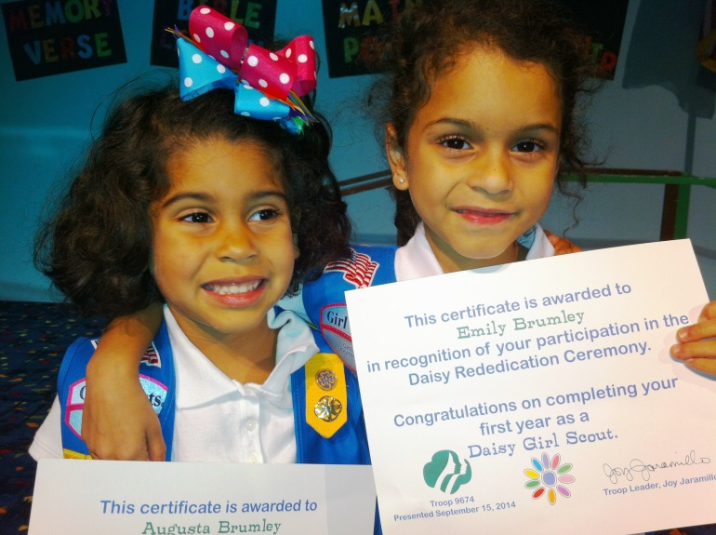

Photo by Kim Brumley

If you contact Kim and let her know what you want, she can probably deliver them at the Chili Supper meeting.

**- - - - -**

**White roses of condolence to Brenda Machen who wrote the following:**

I can hardly believe that I will have to miss another meeting...I am scheduled to be at MD Anderson for my 3 month checkup from Jan. 21 - 23. Then we are leaving for Lafayette, LA to visit Mick's sister and brother-in-law.

We are really not away that much; just seems like it when it comes to making DKG meetings. This is sure one that I hate to miss.

Not sure that everyone got my emails about my mom's passing on Dec. 4th. I was there beside her when she left this world. She was 21 days short of making her 100th birthday. We had already begun serious plans for a big family party. But in typical mom style, she never wanted a big fuss made over her.

I know she celebrated the birth of her Lord at Christmas with the angels singing His praise! And maybe there was a small celebration of her 100th Christmas Day Birthday there too!

**- - - - -**



**Teen Bookfest by the Bay January Update**

Please click and explore the hyperlinks!

Teen Bookfest by the Bay January Update

As of the writing of this article, Teen Bookfest by the Bay is 1 ½ months away. Excited and nervous don’t even begin to describe my feelings! I’ve already started having nightmares about things going wrong, and I’ve started keeping a list by my bedside for those little ideas that wake me up in the middle of the night.

Please remember that you can help us out financially any time you order from Amazon.com without any extra cost for you. Simply access your account through [www.smile.amazon.com](http://www.smile.amazon.com) , search for Teen Bookfest by the Bay, select it as your charity, and begin shopping. Amazon will donate .5% of your purchase amount to Teen Bookfest. It doesn’t sound like a lot, but all of the little amounts can add up quickly.

We did get some bad news. CCISD is going to charge us about $1000 for the use of the Ray High School facility instead of providing it for no charge as we thought originally. We are hoping that the donations come in to cover the amount as it will need to be paid at the end of January to secure the building.

**The big news this month is that the volunteer positions are open and ready!** We are using VolunteerSpot, an online signup and reminder tool, to organize our volunteers.

**Here's how it works in 3 easy steps:**   
1. **Click this link** to go to our invitation page on VolunteerSpot: <http://vols.pt/KSJC8n>   
2. **Enter your email address:** (You will NOT need to register an account on VolunteerSpot)   
3. **Sign up!** Choose your spots - VolunteerSpot will send you an automated confirmation and reminders. Easy!

Note: VolunteerSpot does not share your email address with anyone. If you prefer not to use your email address, please contact me at 241-8112 or **dvanzandt@tmisd.us** and I can sign you up manually.

If you’d like more information, please visit our [website](https://sites.google.com/site/teenbookfest/) , or find us on Facebook ([Teen Bookfest by the Bay](https://www.facebook.com/teenbookfestbythebay)) or Twitter ([@TBFBay](https://twitter.com/TBFBay)).

If you have children, grandchildren, nieces or nephews, or neighborhood kids who are in 8th to 12th grades, please let them know about Teen Bookfest, or better yet…bring them!

Debbie VanZandt

**Alpha State Convention**

[**Click this link to find out why you need to BYOB for the convention.**](http://www.alphastatetexas.org/lonestarnews/2014.winter.pdf)

It is time to begin making plans to attend the 86th Texas State Convention in San Antonio. A good way to begin is by making your hotel reservations right away.

The official convention hotel

is the [Grand Hyatt](https://aws.passkey.com/g/25186170) on the River Walk.

[Convention Website](http://86thtsoconvention.weebly.com/)

.

**For Those No Time to Fix Dinner Days**

From the “Before **the Bell E-Newsletter”**

[**33 3 Ingredient Slo Cooker Recipies**](http://r20.rs6.net/tn.jsp?f=001a3yNPfUlTNbajzYyLpOxJBskUw_Dw-LZSQjOV6zHy7N_3hO92oHpoOFvArcJukEtyQJvrOJmvaOsjD1bXrTLVeK_r8gJiInL_NZeWg1GqAfv9r8P4VWhzcgRN0ZlVqmTKpnulC8TEVtxCOPmIDvueXPRCDbDfJHWEnudw6v5OK1VJrdmDIf_4y7hwVu_BTKUE081FopBBmKWEnFbMh5YJZXoNToEVD49-q6R0fIFHI5cESPK_oYIFQ4ugcpuz1m27QaU8SLwLzHVboaP-fZrK6adEMzjO5cg-L5GUAQ6PxZXaMeW6lLcB1I7wayZxTfv4WSl6xktMk1h2dpqdScOOQ==&c=RJhUdWssKsVstnA465xCPs7gQ_JatnXcY3hdamvY0Xmsepvrbr1bWA==&ch=KS_M0cFx3UnVUtBSF40bADUcfjUoCbA4YDJJ74aw0q_-W4ButkPo1Q==)

**Any change in your contact information?**

If so, please notify Carol Walker @ 937-3604 or [walkerbc64@msn.com](mailto:walkerbc64@msn.com)

Microsoft Word clip art

**Get Connected!**

Want to avoid copyright infringement? Discover some sources of freely usable media. Read the January/February issue of *Get Connected!* [here.](http://www.alphastatetexas.org/pdfs/communications.connected.2.pdf)

**Think Scholarships NOW!**

Our Esther Jane Roark Hahn Memorial Recruitment Grant is awarded to a resident of the Coastal Bend pursuing a career in the field of education. The grant is for $300.00 and may be used for tuition, registration fees, books or supplies. The applicant may be enrolled in any level of education with the transcript reflecting an overall average of at least 2.0. Preference is given to relatives of Theta Gamma members.

Do you have a student or a family member that meets these qualifications? If so, please remember the application is due to the Scholarship Committee **before April 1**.

As a member of Theta Gamma you are eligible to apply for the May Blythe Theta Gamma Scholarship. You must have been a member of Theta Gamma for at least one year. The scholarship is for $300.00 and may be used for tuition, fees, books or supplies at a non-society continuing professional education event, seminar, workshop, or graduate class.

Remember the scholarship does not have to be used for a formal classroom setting course. Some of you may be passing up free money. The application is due to the Scholarship Committee before April 1.

**Applications are in your yearbook and also attached to the email in which you received this newsletter.** Please open and print out the application you need. Fill it out and bring it to the next meeting, email, or mail it to our scholarship chairman:

Mrs. Bettie Ruth Mitchell,

4729 Sea Island Drive 78413

[**betmitchell@yahoo.com**](mailto:betmitchell@yahoo.com)