**Theta Gamma Thoughts**

Theta Gamma, Chapter # 195, Area V, Corpus Christi

The Delta Kappa Gamma Society International, Texas State Organization

Volume # 47 Issue # 06 March 2015

Mission Statement: The Delta Kappa Gamma Society International promotes professional and personal growth of women educators and excellence in education.

Leading Women Educators Impacting Education Worldwide

Editor: Carol Walker [walkerbc64@msn.com](mailto:walkerbc64@msn.com)

**President’s Message**

Hello Sisters,

Once again we are going to do our annual purse project. I am going to give you a list of what is needed this year. They have asked for 24 purses, but we will fill as many as we can and they will have a few extras. I have been doing some shopping prior to writing this and saw a few things to pass on to you.

At the Dollar Tree, they have a pack of three full size toothbrushes with covers for a dollar. I was thinking some of you can get together and get 3 for a dollar! I also bought a pkg. of 36 Emory boards for a dollar… those can be shared. I found note pads… 5 for a dollar. Same idea – find a sister buddy and share the items. Also at the Family Dollar, they had small purse size calendars and calendar booklets for 50 cents.

I have bought all of the tissue for everyone at the Dollar Store. Sylvia G. offered to put Q Tips in snack baggies for us and said she could get pens donated and Kim Brumley has a donation of 25 calendar/planners for our purse project so if you have a list from Nolan’s, cross those out.

**Items to buy**

Body Spray Toothpaste

Toothbrush Nail polish Manicure items Hand sanitizer

Compact mirror Shampoo / conditioner

Deodorant

and, of course, the Purse

Please bring your filled purse to the April Meeting. If you have any extras things that someone might have donated, please bring the extras to the meeting and we will separate them into everyone’s purse to make them even.

If you are not going to be coming to the meeting, anytime you have your purse ready to go, please call me and we will make arrangements to get it from you. I think this list is so much simpler than the past. If anyone has any troubles, don’t hesitate to call me.

Thanks, Shannon

**Next Meeting Information:**

**April 23, 2015 5:15 p.m.**

**Miller High School Library**

**Program: “Bucket List”**

[**Miller High School**](https://maps.google.com/maps?bav=on.2,or.r_qf.&bvm=bv.74649129,d.b2U,pv.xjs.s.en_US.ZIOukfQmgko.O&biw=1272&bih=600&dpr=1&wrapid=tljp141019811564310&um=1&ie=UTF-8&fb=1&gl=us&sll=27.795214,-97.422646&sspn=0.0291566,0.0439465&cid=2451827330239612031&q=roy+miller+high+school&sa=X&ei=buoNVJ_YOoaL8QGOloGgDw&ved=0CIUBEPwSMAo)

**Minutes of the**

**February Meeting**

2/19/2015

The meeting was called to order at 5:30 p.m. at Nolan’s Original Poorboys by President Shannon Clubb. Members present were: Shannon Clubb, Laura Day, Neva Gentry, Sylvia Gonzalez, Norma Janice, Brenda Machen, Libby McGee, Bettie Mitchell, Luanna Ortiz, Donna Rodenberg, Beverly Tackett, Linda Uballe, Debbie VanZandt, and Judith Whitlock.

The minutes were approved as printed in the newsletter.

Linda Uballe presented the treasurer’s report. Beginning balance on hand was $1049.38. Deposits of $53.01, and disbursements of $30.06, bring the ending balance on hand to $1072.33. The report was approved and filed for audit. Shannon reminded everyone that money ($17) for the Joint Chapter luncheon needs to be turned in to Linda ASAP. The luncheon will be held at 11 a.m. on March 7th at First Baptist Church.

Corresponding Secretary Luanna Ortiz reported that she had send get well cards to Annette Rusch who has encephalitis and Sheryl Minnek who is recovering from knee replacement surgery.

Shannon reported that 60 pillowcases were delivered by herself and her daughter, Catalina to Shriner’s Hospital in Houston. The Theta Gamma chapter is now part of the 1 million pillowcase challenge and received a thank you letter from Shriner’s Hospital. Shannon reported on the good that Shriner’s is doing for children and their families. Bettie Mitchell added that Shriner’s Hospital is partnering with Rice University on a project to make working hands for children who don’t have them.

Discussion on chapter shirts was tabled until our April meeting.

The Crazy Picasso fundraiser did not perform as such. In order to receive any money from Crazy Picasso, a minimum of 50 people needed to attend. We had an attendance of 35. Everyone who attended enjoyed the event, so it was renamed a Fun-raiser instead.

The Purse Project will still go on, even though no funds were raised for the project. The list of items is smaller this year. It includes: a purse-sized calendar or planner, body spray, pens, toothpaste and toothbrush, nail polish, manicure items, shmpoo and conditioner, compact mirror, deodorant, hand sanitizer, tissues, and Q-tips. Shannon said that the tissues and Q-tips would be provided, and that the gift cards and bus passes would not be included this year. The smaller list and lack of cards included will cut down on the price of the purses. Members are encouraged to bring their purses to the April meeting.

Debbie reported that Teen Bookfest is less than 2 weeks away and things are going well. There will be one more planning meeting before the event, but volunteers are still needed. She said that she is looking forward to giving her report at the next meeting to let everyone know how well the event went.

The basket for the drawing included 3 $15 gift cards, 1 each to Hester’s Restaurant, Taylor Center Deli, and Starbucks and was won by Brenda Machen. Donations raised for the basket were $49.

The Pride and the Prize Pop Quiz question from the February newsletter was “Where and when is the Spectacular Texas Art Retreat going to be held in 2016?” Members were instructed to visit the Alpha State website to find the answer. The STAR retreat will be held at Camp Allen in Navasota on February 19-21, 2016. The winner of the drawing and a gift card was Sylvia Gonzalez.

The Pace donation was for the Golden Gift Fund. Formed in 1979 to commemorate the Society’s 50th Anniversary, the Golden Gift funds the Leadership Management Seminar. The donation this night amounted to $5.69.

The meeting was adjourned at 6:15 p.m. and followed by a program on The Healthy Heart presented by Lari Ainsworth, a retired principal from the Tuloso-Midway school district.

**Future Meetings**

**May 21,** 2015 515 p.m.

Sugarbakers Restaurant on Santa Fe

Our recruitment grant scholarship and May Blyth grant to a member will be awarded at our **Founder’s Day/Birthday celebration**.

[Sugarbakers Restaurant Map Link](https://maps.google.com/maps?rlz=1T4ADRA_enUS401US402&q=2766+Sante+Fe+Corpus+Christi,+TX+78404&um=1&ie=UTF-8&sa=X&ei=-ewNVKiIH6Xu8AHE5IGwDw&ved=0CAgQ_AUoAQ)

**Take Pride - Win a Prize**



Having just supported Teen Book Fest, look at some of ours sisters that are published authors!

Visit dkgtexas.org Resources

TSO Authors

The list is from 1906 - ? Answer the question and bring it to our next meeting!

The list is amazing!**!**

Bring your answer to our meeting for a chance to win a fabulous prize!

**Red Roses of**

**Thanks to**

Neva Gentry on behalf of myself and CASA of the Coastal Bend for your generous donations of three sets of sterling silver earrings and one sterling silver pendant valued at a total of $210 towards the Sparkling City's 2015 Mardi Gras Ball's silent auction.  CASA greatly appreciated your support for the foster children and would like you to know that with your help a difference can and will be made in foster children's lives. Donna

**Congratulations to**

our ownDebbie VanZandt, who was president of the “Teen Bookfest by the Bay” planning committee and our other sisters who were among the people who made this event a reality.

[**http://www.caller.com/entertainment/family-fun/learn-to-tell-your-story-at-teen-bookfest-by-the-bay_84363696**](http://www.caller.com/entertainment/family-fun/learn-to-tell-your-story-at-teen-bookfest-by-the-bay_84363696)

The link is to the article that was in the Corpus Chriti Caller/Timesbefore the event and the following is afterwards.

<http://callertimes.tx.newsmemory.com/?_ga=1.135085817.905984151.1418744514>

Click on “pages” and go to B3.The top photo and caption are a follow up to Teen Bookfest by the Bay.

**Think Scholarships NOW!**

**Applications must be in the hands of the Scholarship Committee before April 1.**

Our Esther Jane Roark Hahn Memorial Recruitment Grant is awarded to a resident of the Coastal Bend pursuing a career in the field of education. The grant may be used for tuition, registration fees, books or supplies. The applicant may be enrolled in any level of education with the transcript reflecting an overall average of at least 2.0. Preference is given to relatives of Theta Gamma members.

Do you have a student or a family member that meets these qualifications?

As a member of Theta Gamma you are eligible to apply for the May Blythe Theta Gamma Scholarship for $300.00 and may be used for tuition, fees, books or supplies at any non-society professional education event, seminar, workshop, or graduate class. Remember the scholarship does not have to be used for a formal classroom setting course. Some of you may be passing up free money. The application is due to the Scholarship Committee before April 1.

**Applications are in your yearbook and also attached to the email in which you received this newsletter.** Fill it out and bring it to the next meeting, email, or mail it to our scholarship chairman:

Mrs. Bettie Ruth Mitchell,

4729 Sea Island Drive 78413

[**betmitchell@yahoo.com**](mailto:betmitchell@yahoo.com)

**Alpha State Convention**

[**Click this link to find out why you need to BYOB for the convention.**](http://www.alphastatetexas.org/lonestarnews/2014.winter.pdf)

It is time to begin making plans to attend the 86th Texas State Convention in San Antonio. A good way to begin is by making your hotel reservations right away.

The official convention hotel

is the [Grand Hyatt](https://aws.passkey.com/g/25186170) on the River Walk.

[Convention Website](http://86thtsoconvention.weebly.com/)

**Any change in your contact information?**  If so, please notify Carol Walker @ 937-3604 or [walkerbc64@msn.com](mailto:walkerbc64@msn.com)

**Our Books for the Phillipines Project**

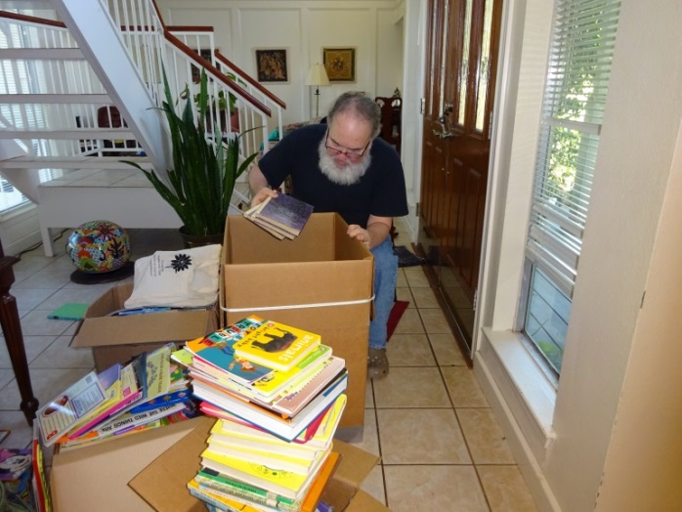

Neva’s son, Tom as he packed books donated by Theta Gamma and Neva’s church.



Photos by Marie Gentry

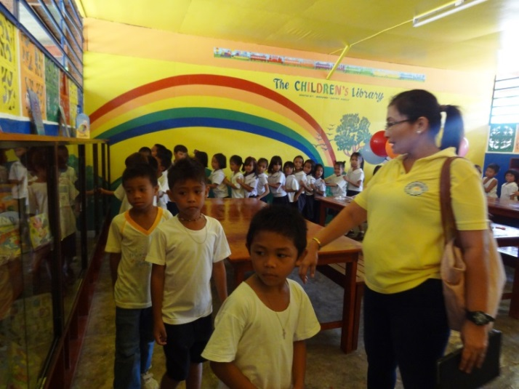

These were sent to The Children’s Library recently built by Tom’s wife, Marie, and her family in the Philippines on family owned land they donated to the adjacent Anito Elementary School that had no library and almost no library books for the children.

**Teen Bookfest by the Bay Report**

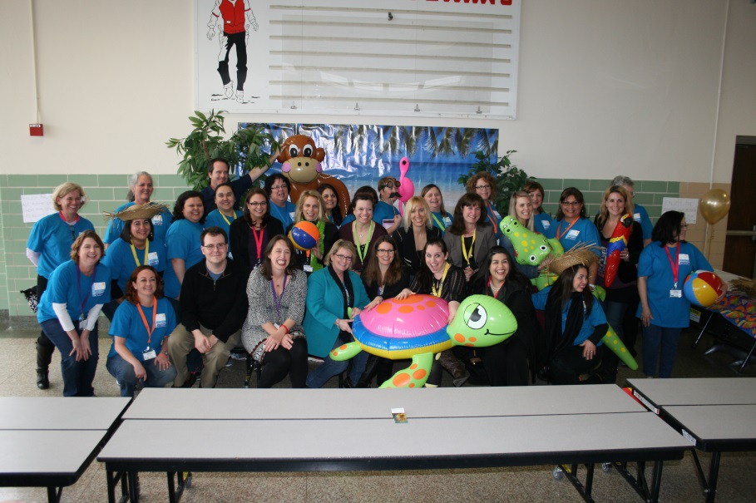

The first annual Teen Bookfest by the Bay is all over and planning has already started for the second annual Teen Bookfest by the Bay!

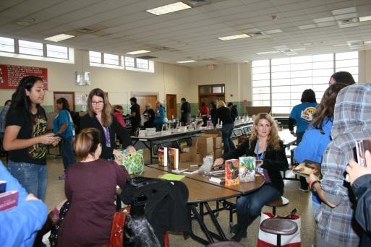I’m pretty sure that calling the event a success is no understatement. All of the authors made it in, although Victoria Scott was late because of the weather in Dallas, and Beth Fehlbaum had to leave early because she got ill suddenly. Over 300 teens came to hear and talk to the authors. When the authors weren’t presenting in their panels, many of them hung out in the Ray HS cafeteria where the kids were. So not only did the kids get to hear them talk about their books, but they also got to talk to them one-on-one and get autographs and pictures with them, too. At the end of the event, every teen got a free book, courtesy of a donation by the Junior League.

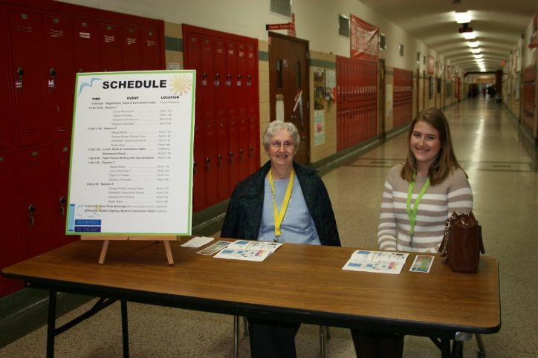We put a feedback survey in the printed program and got some good suggestions from teens who attended. We also heard back from some of the volunteers and authors. We knew that there would be glitches (luckily they were small), and we have some ideas about how to fix them for next year’s event. In our debriefing meeting, we went over our list of “Notes for Next Year” and began planning for Teen Bookfest by the Bay 2016.

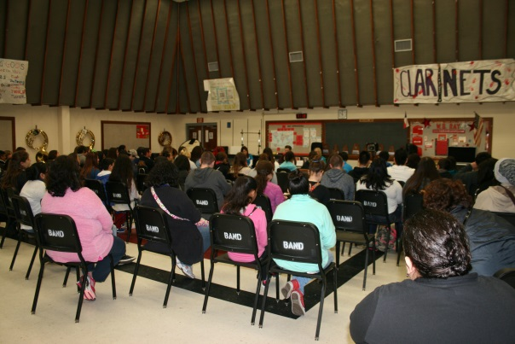 We appreciate the support, both financial and volunteer, that we got from Theta Gamma this year.

Debbie VanZandt