The Delta Kappa Gamma Society International
Leading Women Educators Impacting Education Worldwide
Theta Gamma Thoughts
Alpha State Texas Corpus Christi, Texas
Area V
Volume 45 Theta Gamma
Number 01 Chapter # 195
September 2012
Editor: Carol Walker walkerbc64@msn.com

The Delta Kappa Gamma Society International promotes professional and personal growth of women educators and excellence in education.
Dear Theta Gamma Sisters,

Explore the Possibilities – Let Our Vision Light the Way!

I am honored to be a sister in Delta Kappa Gamma and your president of Theta Gamma Chapter. As educators, we explore the many possibilities as we instruct our students, collaborate with fellow colleagues, and envision the future. As members of Delta Kappa Gamma, we have the same task before us in the upcoming year.

The Executive Board met and began planning for our year that is to be filled with many possibilities for growth in our chapter and a commitment to serve our community.

Our September 20th meeting will enable committee members and chairpersons to discuss their committee responsibilities in a small group as they plan for the upcoming year. The chapter service project(s) will also be a topic of discussion.

I am looking forward to seeing each of you and I know you are looking forward to exploring our many possibilities as we plan as a visionary chapter.

See you in September,
Donna

Next Meeting Information:

Thursday, September 20th
5:15 PM, at the TM Middle School Library 9768 La Branch Corpus Christi, TX 78410

Here is a link to the map. Angela's Library at TM Middle School

Pay your dues ($76 – check made to Theta Gamma) at the meeting
or send them as soon as possible to
treasurer Linda Uballe, at 3102 Santa Fe # 4C, 78404

Minutes of the May Meeting
Theta Gamma
May 5, 2012
Kay Schroeder’s House

Kay Schroeder welcomed everyone to her home and described the delicious Greek food we would have for lunch. As we ate, we filled out a Chapter Survey and a member profile.
REPORTS
Attendance
Members present - Brandey Addison, Elnora Corbin, Margaret Deville, Leslie Jo Elmore, Neva Gentry, Sylvia Gonzalez, Norma Janice, Libby McGee, Bettie Ruth Mitchell, Donna Rodenberg, Eileen Rogers, Kay Schroeder, Nancy Shaheen, Beverly Tackett, Linda Uballe, Carol Walker, Debbie Van Zandt, Vilma Zuniga, and Michelle Richer. We had two guests, Kitty Hutchcroft, who spoke to us about the Area V workshop and the State Convention and Barbara Schultz, Beverly Tackett’s sister.
Members absent - family: Brenda Machen, Shannon Clubb, Sarah Moore, Shayla Floyd, and Angela Steagall. professional: Judith Whitlock. illness: Theo Wagner.
April minutes were approved.
Linda Uballe gave the treasurers report. The balance on hand as of April was $1969.39. Deposits were PACE $15.05, Basket $75.00, and bank interest $.02. Total deposits were $90.07. The available funds are $2059.46. Disbursements were to DKG $332.00, Shayla Floyd $20.97, EJH Scholarship $500.00, and TSO Area V Workshop $125.00. Total disbursements equaled $977.97. The balance on hand is $1081.49.
NEW BUSINESS
The Esther Jane Hahn Scholarship was awarded to Ben McGee, son of Libby and Ron McGee. Ben was unable to join us but he did send a note. Libby read the note in which, Ben thanked us for awarding him the scholarship not once but twice. His plan is to transfer to the University of Texas in San Antonio in the fall. His dream is to become an educator of music.
Kitty Hutchcroft shared a few details about the State Convention which is June 21-23. The Omni has rooms available. The cost is $50.00 plus meals. CPE credits will be available.
Ms. Hutchcroft also had information on the Area V Workshop on August 11. The workshop will be held at the La Joya Palmview High School in Mission. Breakfast will be at 8:30 and you will be finished by 1:00. The main speaker will be Carmen Garza and she will speak about TRS. There may be other speakers. Hopefully, CPE credits will be available. We are responsible for a jewel box costing between $25.00 - $30.00. Registration is $20.00. Theta Gamma has paid for five people to go. If anyone else wishes to attend, they will be reimbursed. Kay Schroeder mentioned that she has a friend with a house and pool that we could use for overnight.
PROGRAM
Donna Rodenberg presented the program-“Could You Be a Founder?” She passed around handouts for members to read and answer the question - could you be a founder? Annie Webb Blanton founded The Delta Kappa Gamma Society International. Twelve women were selected as founders. We found out that we could be founders. The handout discussed each of the twelve founders’ backgrounds. The information was from Volume I of Our Heritage. Gladys Jane Brainard, Kappa Alpha State, Texas used this idea on September 18, 2005 and gave permission for it to be used at any Delta Kappa Gamma program.
The new officers for the next two years were installed by outgoing President, Kay Schroeder. The new officers are President, Donna Rodenberg, Shayla Floyd, first vice president, Brandey Addison, second vice president, Angela Steagall, recording secretary, Debbie Van Zandt, corresponding secretary and Linda Uballe will continue as treasurer. Kay Schroeder and Eileen Rogers are retiring from their leadership rolls. Roses were given to each new officer. Kay said good bye as the outgoing president.
Recognition was given to Elnora Corbin for being a member of Theta Gamma for fifty years. We sang the birthday song and had cake. Delta Kappa Gamma is 83 years old and Theta Gamma is 46 years old.
Sincerely,
Eileen Rogers, Recording Secretary

Red Roses to:
Heather Howse-Rohmfeld who completed her Master’s degree in counseling at TAMUCC
Kim, Donna, and Brandey for attending the State Convention and Kim, Donna, Brandey, and Kay for attending the Area V Workshop.
At the State Convention At the Area Workshop
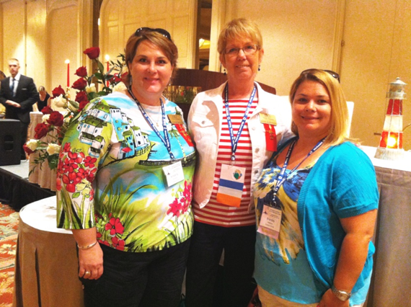
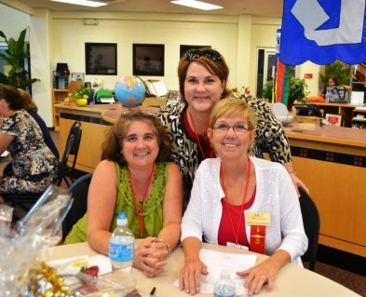

Kim. Donna and Brandey Kay, Kim, and Donna
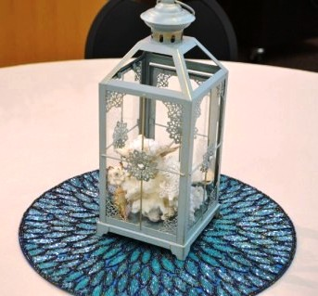
Each chapter in Area V created a centerpiece to serve as a door prize. The theme was to be associated with "jewels" as the workshop was held in LaJoya. Theta Gamma created a centerpiece with a jeweled placemat and a lantern filled with seashells representing our Sparkling City by the Sea.
WE - Theta Gamma - will be the host chapter for Area V Workshop in 2014 along with our other sister chapters, Beta Xi, Gamma Psi, Delta Chi, and Delta Psi.

White Roses of Remembrance for:

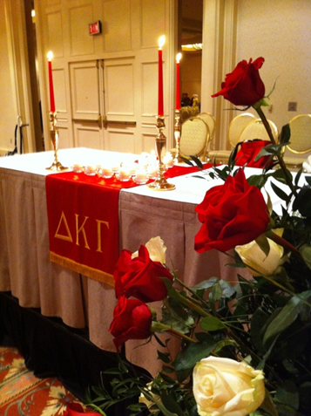

our dear sister, Theo Wagner, who died in June

Here's a photo of the table honoring Theo that
Kim took at the State Convention.

Be sure to get your Recommendation for Membership forms in to Donna before the meeting on the 20th. They were sent to you in the meeting notice. If you’ve lost it, email walkerbc64@msn.com for another one.

Future Meetings

October 18th, Chapter Orientation
November Initiation (Beta XI is hosting) TBA
December 6th, Fellowship and Fundraising through Bunco
at the home of Brandey Addison, 3833 Julia Lane, 78414
January 17^{th,} Annual Chili Supper at Kim and Donna’s Home
February 21st, Professional Affairs and Legislation at the TAMU Alumni Association
Leroy DeHaven, TRTA District Presidents Council Vice-Chairman, and
Nancy Benson, President of the Corpus Christi Retired Teachers Assn.
March – Joint Chapters’ Luncheon (Delta Psi is hosting) TBA
April 18th, in the Computer Lab at TM Intermediate School for “Printerest”
May16th, Founders Day and Chapter Birthday at Chef Mark’s

Quick Links to our society sites:

International: http://www.dkg.org

State: http://www.alphastatetexas.org/ Be sure to take a look at the information in the committee reports especially the ones in which you have a chapter position.

Theta Gamma Chapter: http://www.orgsites.com/tx/thetagamma/

Have You Changed Your Address/Phone/Email?
If you have changed anything about your address, phone or email -

please notify Carol Walker at 937-3604 or walkerbc64@msn.com
and
Treasurer, Linda Uballe at 537-5762 / 882-6628 or ljuballe@sbcglobal.net

Take the time to find and wear your pin to the next meeting—you’ve earned it.
Members still employed are also encouraged to wear theirs to work on the first Monday of ery t every month. Show our organization off to others – we may pick up a new member that way.

Interested in a Name Badge?

They are available at the State Convention where Iota Omicron sells them. You can also order directly from Annetta Reusch of that chapter.

The badges are $13 unless 10 or more or ordered together. That way they save postage. The check and a note telling her you are a member of Theta Gamma and how you want your name spelled on the badge can be sent to her at 42 Surrey, Iowa Park, TX. 76367. Her email is irislovr@clearwire.net

Make checks payable to Iota Omicron. If you send her an email, she will get it ordered and when your check arrives, she will mail it. It usually takes about a week to week and a half.

