The Delta Kappa Gamma Society International
Leading Women Educators Impacting Education Worldwide
Theta Gamma Thoughts
Alpha State Texas Corpus Christi, Texas
Area V
Volume 45 Theta Gamma
Number 03 Chapter # 195
November 2012
Editor: Carol Walker walkerbc64@msn.com

The Delta Kappa Gamma Society International promotes professional and personal growth of women educators and excellence in education.

Dear Theta Gamma Sisters,

Wow! Santa Claus arrived at the mall on November 8th and I am sure there is still Halloween candy to be eaten! So, the celebration that gets squeezed in is of course Thanksgiving.
During the course of my 22 year career as an educator, the Thanksgiving holiday required many projects. They ranged from making paper turkeys, placemats, t-shirts, and writing about being thankful. With the writing aspect, I wanted to make sure my children truly understood what being thankful meant. My class wrote to their parents, classmates, and several times, my class was asked to write for the local newspapers about being thankful. Our writing would begin with ideas shared by all. Many children were thankful for their homes, family, friends, and pets. Then there were those that were insistent on Nintendo, skateboards, footballs, and what we called those material things. So, as a teacher, I tried to direct them to think beyond those things. The outcome of these conversations went back to what I thought they should have been thankful for in the first place. My children would tell me that they know their parents work hard so they can give them those things. Playing Nintendo was something that the family did together. A football was taken to the park on a Saturday. Once again, I was the teacher who was taught by my children. And right they were.
After that, we decided to begin Thankful Thursdays. We simply would give thanks for ANYTHING and shared this with each other and wrote about it throughout the year. Giving thanks was never squeezed in between Halloween and Christmas again. It was celebrated before Santa arrived and long after he returned home.
Thankful Thursday can be EVERY DAY like it was for my children. I hope they are still reminded of this. I know I am.
Just a thought,
Donna
Next Meeting Information:

December 6 at 5:15 PM
At the home of Brandey Addison 3833 Julia Lane Map to Brandey's Home

“To Die for Holidays”
Members will enjoy a social night of scholarship fund fundraising by playing bunco.

Please bring $5.00 to play Bunco. All proceeds will benefit the scholarship fund. Prizes will be awarded for Bunco. We will not have a basket raffle at this meeting. It is going to be great fun! if you would like to BYOB of Holiday Cheer you may. Soda and tea will be provided.

PACE monies will be sent to the Educational Foundation Fund

December Meeting Responsibilities:

Shannon Clubb (Basket Chairman) will contact her committee: Shayla Floyd, Linda Uballe, Brandey Addison, and Laura Day Brown

Drinks and Ice, Kimberly Craig, Paper Goods, Christy Solis, sweet, Kimberly Craig, Sharon Phillips, and Roxanna Guerrero,

Savory/Salty, Shannon Clubb, Laura Day Brown, and Angela Steagall

If you are unable to bring your item(s) to the meeting, please switch with someone.

Please contact Michelle Richer if you have questions or are unable to bring the item/items to the meeting.
Michelelsr2@aol.com or 850-1879 or 443-8389

Minutes of the October Meeting

Theta Gamma Chapter
Minutes of Regular Meeting
October 18, 2012

The regular meeting was called to order at 5:30 by President Donna Rodenberg. After an inspirational reading by Carol Walker, the minutes of the last meeting were approved as read with no corrections. Correspondence reported a thank-you from Carol Walker for her card that she received. Cards will be sent to Nancy Shaheen with encouraging thoughts and Heather Howse-Rohmfeld with congratulations on the birth of a baby girl.

The treasurer Linda Uballe reported a balance as of September 20, 2012 of $2156.91. Membership dues will be sent to State on October 30, 2012.

Donna Rodenberg presented a new sign-up sheet for refreshments and scholarship basket. Each member was encouraged to sign-up for two meetings. Dates of future meetings were provided.

Leslie Jo Elmore presented the name and profile of a new prospective member. Wendy Morris was accepted unanimously by secret ballot.

Three new chapter projects were presented for discussion. The three projects are: Women’s Shelter “Fill-A-Purse” Project for Christmas, Box Tops for Education, and Mentors for New Teachers. All three were well received by members.

Laura Day Brown moved and Brandey Addison seconded the motion that we approve the Women’s Shelter project. A voice vote was taken and the motion passed. More information about the purse and contents will be forth coming.

The project, Box Tops for Education, possibly Wesley Community Center, needed more information before a vote from members. Committee members will gather more information and report at a later date.

The project, Mentors for New Teachers, was presented by Kimberly Brumley. She opened with ways that we can be mentors to new teachers and be aligned with an international project.
Statistics show that CCISD has 700 teachers with 0-5 years of experience and 50 new teachers. Kimberly will provide more research. No vote was taken.

Membership and Research Committee members, Brandey Addison, Libby McGee and Laura Day Brown gave an orientation for the new members. Each new member shared her personal information and received a welcome to Theta Gamma Chapter. Donna Rodenberg gave a review of the meetings. Kim Picozzi shared the history of Delta Kappa Gamma in the format of a game, “Who has ___? I have ___.”

The PACE collection was announced as $14.49 and the monthly scholarship raffle earned $61.00.

The scholarship raffle basket drawing was held and Judith Whitlock was the winner.

The president adjourned the meeting at 7 pm and Kimberly Brumley led us in our song.

Beverly Tackett

Future Meetings

January 17^{th,} Annual Chili Supper at Kim and Donna’s Home

February 21st, Professional Affairs and Legislation at the TAMU Alumni Association
Leroy DeHaven, TRTA District Presidents Council Vice-Chairman, and
Nancy Benson, President of the Corpus Christi Retired Teachers Assn.

March 9th – Joint Chapters’ Luncheon at Trinity Towers, 101 Upper North Broadway
April 18th, in the Computer Lab at TM Intermediate School for “Pinterest”

May16th, Founders Day and Chapter Birthday at Chef Mark’s at Six Points

Red Roses to:
Margaret DeVille who was a judge in the recent “2012 Caller-Times/Citgo Distinguished Scholars Awards”. Margaret judged the entries in the Technology category.

and

Cynthia Besosa whose new parents are
grandbaby was born 10/18 Cassia and Bryan Erwin
weighing 5 lb.15 oz.

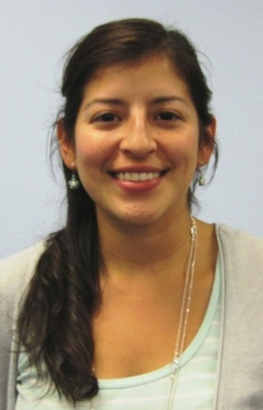
Meet Our Newest Sisters
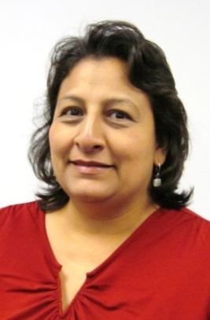
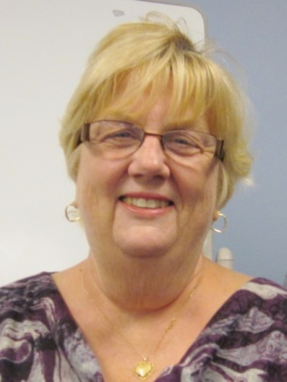

Sharon Phillips Roxanna Guerrero Christy Solis
Retired TMISD CCISD - District Instructional Coach Second Grade Teacher at TM
Teacher of the Visually Handicapped
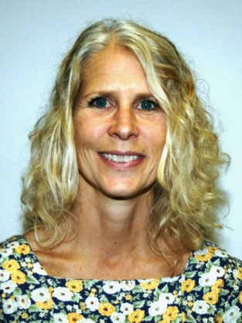
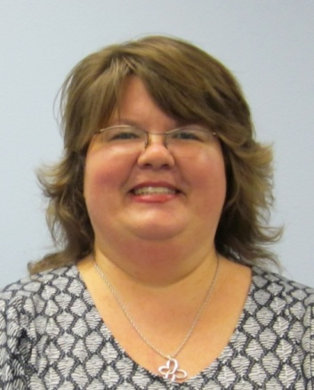

Kimberly Craig Wendy Morris
CCISD Instructional Coach Calallen High School Science Teacher
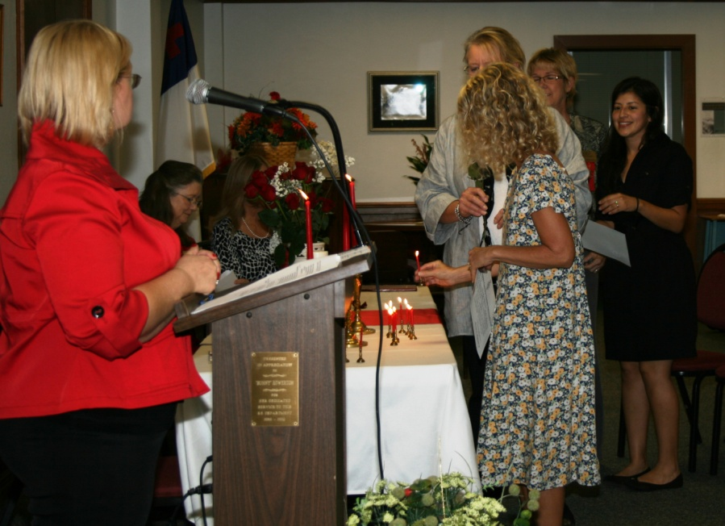
Our Newest Retirees Initiation Scene
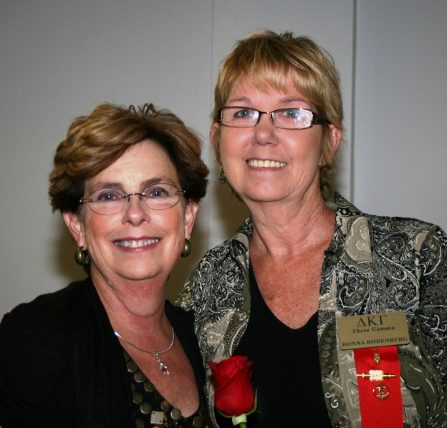

Eileen and Donna

State Convention
Former Theta Gamma president Sandra Morales has shared an update on convention plans with us.

“The Steering Committee has had several meetings and each one has been jam-packed with exciting information. Some will be shared with you in the winter issue of the Lone Star News. At this time, I will tell you that there are a lot of "surprises" in the works that I think you will really enjoy. We've been revamping, remodeling, and reorganizing sessions and I think you will love the "new and improved" look.

But, in order for you to agree, you must attend the convention--so save the dates, June 20-22, and make plans now to attend and be a major and very visible part of the 84th Texas State Convention at the Renaissance Hotel in Austin.

State Scholarships

The Texas Organization of The Delta Kappa Gamma Society International has several generous scholarships available to its members. There are scholarships available for graduate studies, continuing adult education, and educational travel. Scholarship information, instructions, and application forms may be printed from the links on this page.

The following documents are Adobe Acrobat PDF versions. The applications are interactive and savable.

Scholarships Guidelines and Applications
2013 TSO 3 Hour Graduate/Undergraduate Scholarship Guidelines
2013 TSO 3 Hour Graduate/Undergraduate Scholarship Application
2013 TSO 6 Hour Graduate/Undergraduate Scholarship Guidelines
2013 TSO 6 Hour Graduate/Undergraduate Scholarship Application
2013 TSO 9 Hour Graduate/Undergraduate Scholarship Guidelines
2013 TSO 9 Hour Graduate/Undergraduate Scholarship Application
2013 TSO Adult Education Scholarship Guidelines
2013 TSO Adult Education Scholarship Application
2013 TSO Doctoral Scholarship Guidelines
2013 TSO Doctoral Scholarship Application
2013 Guidelines for Maetha Griffin Weatherby Educational Travel Scholarship
2013 Maetha Griffin Weatherby Educational Travel Scholarship Application
TSO 2012 Mini-Grant Guidelines for October Application
TSO 2012 Mini-Grant October Application

Quick Links to our society sites:

International: http://www.dkg.org

State: http://www.alphastatetexas.org/ Be sure to take a look at the information in the committee reports especially the ones in which you have a chapter position.

Theta Gamma Chapter: http://www.orgsites.com/tx/thetagamma/

Have You Changed Your Address/Phone/Email?
If you have changed anything about your address, phone or email -

please notify Carol Walker at 937-3604 or walkerbc64@msn.com
and
Treasurer, Linda Uballe at 537-5762 / 882-6628 or ljuballe@sbcglobal.net

Take the time to find and wear your pin to the next meeting—you’ve earned it.
Members still employed are also encouraged to wear theirs to work on the first Monday of every month. Show our organization off to others – we may pick up a new member that way.

Interested in a Name Badge?

They are available at the State Convention where Iota Omicron sells them. You can also order directly from Annetta Reusch of that chapter.

The badges are $13 unless 10 or more or ordered together. That way they save postage. The check and a note telling her you are a member of Theta Gamma and how you want your name spelled on the badge can be sent to her at 42 Surrey, Iowa Park, TX. 76367. Her email is irislovr@clearwire.net

Make checks payable to Iota Omicron. If you send her an email, she will get it ordered and when your check arrives, she will mail it. It usually takes about a week to week and a half.

A limited number of Women Teachers to the Calling Cookbook… is available for purchase.
The book has 600 recipes and far more quotes, memories, and stories from the 2009-11 biennium. Special indexes are included to recognize not only the recipes and contributors but the persons who are quoted, chapter newsletters, chapters, and all members who so faithfully contributed to two very successful DKG years in Texas. There is no commitment to cook with this purchase; only to read and enjoy!

If you have not purchased this book of delicious recipes, worthy quotes and joyous memories, I encourage you to do so as soon as possible. Please indicate if you wish the cookbook to be autographed and dated. (I learned from the Archivist at Texas Woman’s University that this makes it more valuable.) Also, if you would like a personal note, please let me know. I will be happy to accommodate each of you.

Each book is $20.00 including shipping and handling. Profits benefit scholarships. Make your check for $20.00 per book payable to me, Vicki Davis, and mail to PO Box 459, Campbell, TX 75422 as soon as possible. Orders will be filled by postmark as long as the supply lasts.

Thank you so very much for ordering a cookbook. It's been a fun experience working on the cookbook and hearing from each of you. I hope you enjoy reading and using it. There is sure to be a great recipe and/or quote for the upcoming seasonal festivities.

Smile…perhaps the following check list will help you.

Check List:

___ $20.00 per cookbook to Vicki Davis: Check Total: $___________ Check #:__________

___ Name and address where cookbook(s) is/are to be mailed: ______________________________________________________________________________

______________________________________________________________________________

___ I want the cookbook autographed and dated.

___ I want the cookbook personalized as: ____________________________________________

___ Other:

Thank you so much.

Vicki Tigert Davis, Immediate Past State President, Texas State Organization
PO Box 459
Campbell, TX 75422
903-862-3462

PS: The first printing of the book profited $1414 for scholarships! Thank you!

