The Delta Kappa Gamma Society International
Leading Women Educators Impacting Education Worldwide
Theta Gamma Thoughts
Alpha State Texas Corpus Christi, Texas
Area V
Volume 45 Theta Gamma
Number 04 Chapter # 195
January 2013
Editor: Carol Walker walkerbc64@msn.com

The Delta Kappa Gamma Society International promotes professional and personal growth of women educators and excellence in education.
Dear Sisters,
I recently joined a book study group, a wisdom class. This group is comprised of fourteen + friends that bring a different personal perspective. We meet weekly and have insightful conversation about what we are reading. Eyes are opened and conversations allow time for shared ideas and thoughts. It is a time for each person's experiences and life journey to be shared. If I simply read the book on my own, I would certainly miss out!
My sisters are also a source of wisdom and a blessing in my life. We all have the obvious teaching connection to one another. It certainly goes beyond that as we too have different contributions to DKG. We have made a commitment to DKG with many talents, resources, experiences, and an insight into the future.
As sisters, we share and have moved forward with a project that will greatly benefit our community and the Women's Shelter. We invite friends to be part of our chapter to insure we continue to thrive and open the possibilities for the future.
Sharing ideas for teaching, family, travel, and life in general is part of our time. Supporting one another is a true blessing and gift. Time together is a benefit for each one of us and many others. I hope to see each of you in January so that we can just be together as sisters.
Our next gathering in January will be full of healthy fun, delicious chili, and spicy wisdom!
Looking forward to seeing you,
Donna

Next Meeting Information:
January 17, 2013 5:15 PM
Retirees will host their annual chili supper at the home of Kim Brumley and Donna Rodenberg.
3309 Casa Bonita 215-5127
Bring your project purse to this meeting. If you are unable to come to the meeting, please make arrangements to deliver early or have a sister bring your purse. Each member is responsible for one purse filled with the required items.
Presentation: Women’s Health Topics by Shayla Floyd
Discussion of Proposed New Project(s)

January Meeting Responsibilities:

The retirees have this under control.
If you are unable to bring your item(s) to the meeting, please switch with someone.
If that doesn’t work contact Carol walkerbc64@msn.com or 937-3604

Minutes of the December Meeting
Theta Gamma Chapter
Minutes of Regular Meeting
December 6, 2012

The regular meeting was called to order at 5:37 pm by President Donna Rodenberg, the secretary Angela Steagall being present, in the home of Brandey Addison.

After an inspirational reading by Norma Janice, minutes from the last meeting were approved as read with no corrections.

There was no official correspondence since the last meeting. Norma Janice shared a letter from Rose Gungi who is doing well.

Treasurer Linda Uballe reported the current balance in the treasury is $788.19.

Elnora Corbin gave a report from the Scholarship Committee. She informed all members of the scholarships that are available to members and the upcoming deadlines.

Leslie Jo Elmore gave a report from World Fellowship. She informed the members of the World Fellowship recipients and will bring congratulations in the form of postcards for us to sign in January.

Kimberly Brumley is still working on our Mentoring Project. As she receives necessary data, the project will be discussed in the future.

Shannon Clubb reported that Wesley Community Center cannot participate in Box Tops for Education.. She suggested that if you do not have an organization to support, bring your Box Tops to each meeting and we will share them for donation.

Discussion was brought forth about the Women’s Shelter Purse Project. The deadline was changed to the January 17th meeting so that more time could be given to get the purses together in time to distribute them for Valentine’s Day. Purses should be new and have a week long bus pass, a $10 calling/phone card, gum, candy and snacks, along with a full sized deodorant, shampoo, conditioner, toothbrush and toothpaste inside. We should collect 35 to meet the needs of the clientele at the shelter.

The PACE collection was announced with a total of $10.00 and the monthly scholarship raffle earned $110.

Everyone broke into groups to get snacks and play Bunco for our fun Christmas event. The scholarship raffle for three gift cards was held afterwards, with the winners being Libby McGee, Luanna Ortiz and Donna Rodenberg.

The president adjourned the meeting at 7:00 and we dismissed in song.

Angela Steagall

Future Meetings

February 21st, Professional Affairs and Legislation at the TAMU Alumni Association
Leroy DeHaven, TRTA District Presidents Council Vice-Chairman, and
Nancy Benson, President of the Corpus Christi Retired Teachers Assn.

March 9th – Joint Chapters’ Luncheon at Trinity Towers, 101 Upper North Broadway
April 18th, in the Computer Lab at TM Intermediate School for “Pinterest”

May16th, Founders Day and Chapter Birthday at Chef Mark’s at Six Points

Red Roses to Donna:

Since retirement, I became a CASA volunteer. A CASA is a Court Appointed Special Advocate to speak up for and find permanent homes for foster children in crisis throughout Nueces, San Patricio, and Aransas Counties.

A CASA volunteer is the voice of the child in court. Through professional extensive training you learn courtroom procedures and develop strong communication techniques. When the home is no longer safe for a child, and the child must enter the foster care system, a judge may appoint a committed volunteer called a CASA. The volunteer's focus is on the child, giving hope and help to guide the child to a safe, permanent home.

CASA Volunteers are everyday people, but they are also heros. They recognize the need for the community to get involved and put forth serious effort in helping children who are victims of abuse. The goal is that EVERY child in foster care to have a CASA they can rely on and trust to be their voice in court.

Please ask me about my role as a CASA! I would be happy to share with you.
Donna Rodenberg
CASA Volunteer
For additional information to become a volunteer, please contact John White 361 884-2272
john.white@interconnect.net

Red Roses for sharing News :

From Nancy Shaheen:
We went to Las Vegas and the Grand Canyon for our 50th wedding anniversary! (a few weeks early) We were in college and got married 2 days after Christmas because we were on holiday! It sure makes it hard with all the children and grandchildren to be gone at that time! Besides, they want to be with us on our actual anniversary!

I go back to M.D. Anderson on February 3rd for 2 MRI's and a visit with the neurosurgeon. I will be playing it by ear until after that!! I'm doing well though. PTL!

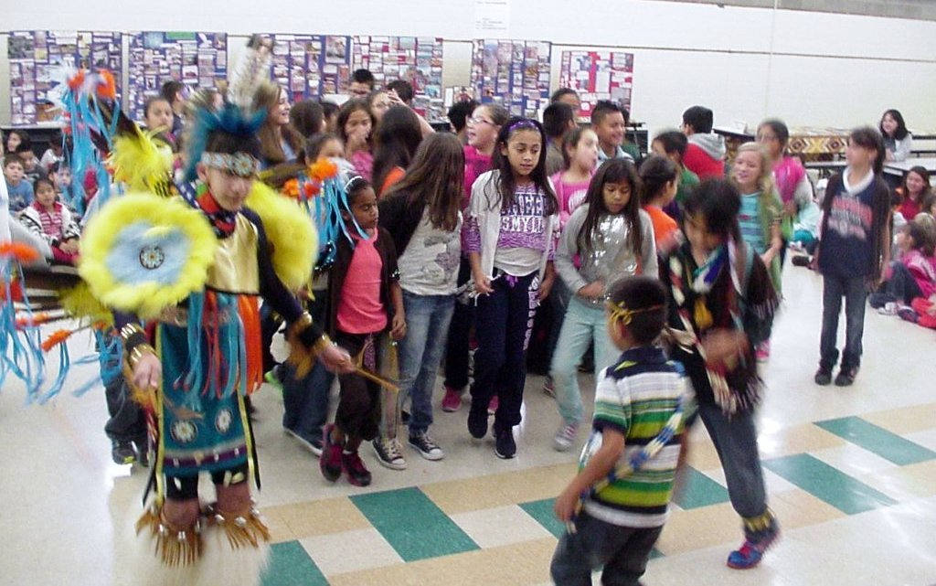
From Sylvia Swift:
Samuel and Cristian Swift (Navajo) along with Stone Castillo ( Lipan Apache in colorful regalia), two high school students from Carroll H. S.(drummer/singers), Mr. Castillo (Chairperson) and myself (Board member)
put on a live Pow Wow at Dawson E. S. for 4th and 1st grade. During the Native American month of November, students had studied (TEKS) the contributions of Native Americans, the history/land and life today.
Students were able to dance and drum; as well.
In the background were hands on displays of the following:
...Navajo landmarks (beautiful land and people)
...Customs and traditions (pictures of Samuel/Cristian) on the Reservation, welcoming of the baby ceremony, their long hair, baby moccasins, etc.
...Code talkers (history and contributions with paintings, photos, and books)
...Samples of petrified wood, coprolite, Painted Desert sand, stones and gems/minerals from New Mexico, AZ.
...Samples of land weathering and pictures (Grand Canyon, Slide Rock, etc.)
...Dinosaur Tracks and history of the finds and how they lived and how they may have perished (Meteor Crater)
...A table with many Native American books was also set up for the children who prefer reading
...A map to locate what tribes lived on their lands today
...Guess what this is? A game to see if they recognized what various things are and what they mean...like Cristian's favorite Kokopeli
...Native American Regalia and why it was used
...The use of the Buffalo, Native diets, tribal life, the purpose of the sheep
...The purpose of drumming, singing and pow wows
...The difference between a pictoglyph and petroglyphs: examples and photos (Canyon De Chelly, Chaco Canyon, Three Rivers in N.M., etc.)
Seen at the December Meeting
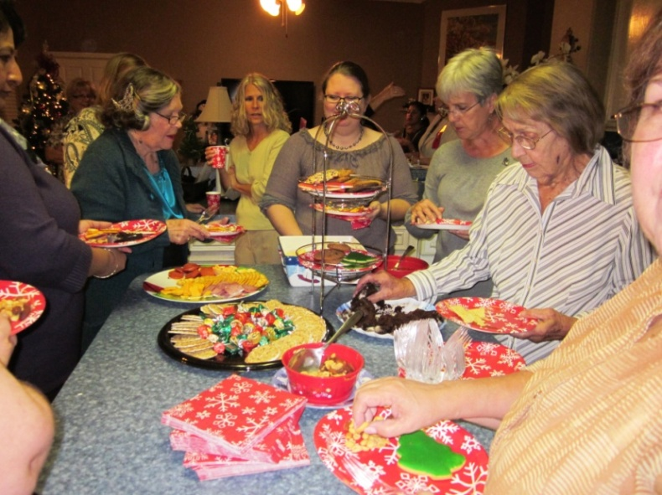
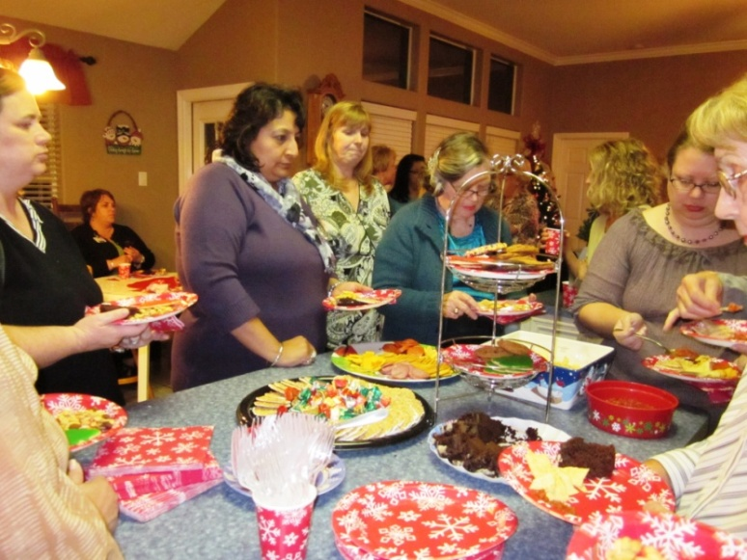

State Convention

Make plans now to attend (June 20-22) and be a major and very visible part of the 84th Texas State Convention at the Renaissance Hotel in Austin.

Quick Links to our society sites:

International: http://www.dkg.org

State: http://www.alphastatetexas.org/ Be sure to take a look at the information in the committee reports especially the ones in which you have a chapter position.

Theta Gamma Chapter: http://www.orgsites.com/tx/thetagamma/

Have You Changed Your Address/Phone/Email?
If you have changed anything about your address, phone or email -

please notify Carol Walker at 937-3604 or walkerbc64@msn.com
and
Treasurer, Linda Uballe at 537-5762 / 882-6628 or ljuballe@sbcglobal.net

Take the time to find and wear your pin to the next meeting—you’ve earned it.
Members still employed are also encouraged to wear theirs to work on the first Monday of every month. Show our organization off to others – we may pick up a new member that way.

Interested in a Name Badge?

They are available at the State Convention where Iota Omicron sells them. You can also order directly from Annetta Reusch of that chapter.

The badges are $13 unless 10 or more or ordered together. That way they save postage. The check and a note telling her you are a member of Theta Gamma and how you want your name spelled on the badge can be sent to her at 42 Surrey, Iowa Park, TX. 76367. Her email is irislovr@clearwire.net

Make checks payable to Iota Omicron. If you send her an email, she will get it ordered and when your check arrives, she will mail it. It usually takes about a week to week and a half.

