The Delta Kappa Gamma Society International
Leading Women Educators Impacting Education Worldwide
Theta Gamma Thoughts
Alpha State Texas Corpus Christi, Texas
Area V
Volume 45 Theta Gamma
Number 05 Chapter # 195
February 2013
Editor: Carol Walker walkerbc64@msn.com

The Delta Kappa Gamma Society International promotes professional and personal growth of women educators and excellence in education.
Dear Sisters,
Happy February! January has come and gone so quickly! As 2013 arrived, some sisters might have made some possible resolutions such as:
- Eat healthy
- Further your education
- Learn something new
- Get organized
- Lose weight
- Volunteer to assist those in need
- Manage stress
- Manage finances
- Spend more time with family and friends
- And others I am sure……….
As I reflected on this year so far, I realized what Theta Gamma has provided. Check this out!
- Eat healthy and lose weight – Shayla Floyd inspired us with her journey and success to lead a healthier life.
- Further your education – many scholarships are available to members and were presented by Elnora Corbin in December.
- Learn something new/get organized – we played Bunco and will learn about Pinterest (personal and professional organizer) in April.
- Volunteer to help others – Fill-A-Purse for the Women’s Shelter.
- Manage stress – support of our sisters that are unable to attend meetings through phone calls, rides to meetings, cards of encouragement and concern.
- Manage finances – Leroy DeHaven with TRTA will address the upcoming legislative session regarding educational and monetary issues.
- Spend more time with family and friends – We welcomed Kimberly, Roxanna, Sharon, Christy, and Wendy into our chapter as new friends.
Upcoming opportunities include:
February 21 – Leroy DeHaven. This would be a great meeting to bring a friend.
March 9 – Luncheon. Great time for meeting other DKG members or seeing friends you miss.
April 18 – Pinterest
May 16 – Founder’s Day and Chapter Birthday
June 20-22 – DKG Convention in Austin, Texas
Whew!
Pretty soon it will be time to plan for the upcoming year. I have no doubt the planning for the next year will include a variety of ways to enhance our chapter and our lives. We have accomplished the goals we set out to do this year. I can’t wait to plan for another!
See you soon,
Donna
Next Meeting Information:

February 21st, Professional Affairs and Legislation at the Woo Sung Lee TAMU Alumni Association Welcome Center, located at 6429 Ennis Joslin Road
Speaker –
Leroy DeHaven, TRTA District Presidents Council Vice-Chairman who will speak to
Current Legislative Topics of Concern to All Educators

February Meeting Responsibilities:

$5 for basket ---- Kimberly Brumley*, Sylvia Gonzalez, Ann Falkner, Gwynetta Hoelscher, Gwen McMath, Roxanna Guerrero,
Drinks & Ice --- Michelle Richer
Paper goods --- Debbie VanZandt
Sweet --- Nancy Shaheen, Christy Solis
Savory/salty --- Gwen McMath, Luanna Ortiz

If you are unable to bring your item(s) to the meeting, please switch with someone and/or
Please contact Michelle Richer if you have questions or are unable to bring the item/items to the meeting.
Michelelsr2@aol.com or 850-1879 or 443-8389

Minutes of the January Meeting
Theta Gamma Chapter Minutes of Regular Meeting
January 17, 2013

The regular meeting was called to order at 6:00 pm by President Donna Rodenberg, the secretary Angela Steagall being present, in the home of Donna Rodenberg and Kimberley Brumley. This was the Retired Members Chili Supper Night! After an inspirational reading by Bettie Ruth Mitchell on healthy bodies and minds, minutes from the last meeting were approved as read with no corrections.
There were two pieces of correspondence since the last meeting, a Christmas card from Area V Coordinator Kay Hutchcroft and a formal invitation from Brandey Addison to the dedication of Zak Kolda Elementary School. Brandey spoke about the energy of this new school and encouraged everyone to attend. Leslie Elmore spoke about the emails her committee sent to fellowship recipients and set up a card signing station to send cards as well. A request for a card was made to be sent to Brenda Machen to lift her spirits.
The treasurer Linda Uballe reported the current balance in the treasury is $788.19 as of December. The current balance on hand is $971.57.
Old business led to the Women’s Shelter Purse Project. The purses will be distributed for Valentine’s Day. Those present were to sign that they brought one to help with keeping up with donations. Box Tops for Education are still being collected for various charities in the area.
The program for the night was brought by Shayla Floyd. She is the new regional manager for Weight Watchers. She encouraged all of us to track our food, make our spaces food-free, and if we must have food, to keep healthy choices available. She also encouraged us to plan ahead for our week as far as food goes, to move more and to eat less, especially at restaurants and fast food places.
The scholarship raffle for a Kohl’s gift card was held afterwards, with the winner being Margaret DeVille. The PACE collection was announced with a total of $20 and the monthly scholarship raffle earned $73.
The president adjourned the meeting and we dismissed in song.
Angela Steagall
Recording Secretary

Future Meetings
March 9th – Joint Chapters’ Luncheon at Trinity Towers, 101 Upper North Broadway
Note: Your check for $12 must be in the treasurer’s hand at the meeting on the 21st or you will not be able to attend.

April 18th, in the Computer Lab at TM Intermediate School for “Pinterest”

May16th, Founders Day and Chapter Birthday at Chef Mark’s at Six Points

Scholarships Available (applications are included with this newsletter)

As a member of Delta Kappa Gamma you are eligible to apply for the Theta Gamma Chapter Scholarship if you have been a member for one year. The scholarship is for $300. It is known as the May Blythe Scholarship and the money may be used for tuition, fees, books, and/or supplies for any non-Society continuing professional education event, seminar, workshop or graduate class.

The deadline to apply is April 1st.

Turn in the application to Donna, or any member of the Scholarship Committee: Bettie Mitchell, chairman, Norma Janice, Elnora Corbin or Carol Walker.

Do you know an aspiring educator? If so have them fill out the application for the Esther Jane Roark Hahn Memorial Recruitment Grant. This scholarship is available for any resident of the Coastal Bend pursuing a career in any field of education. An overall grade average must be 2.0; financial need is not a determining factor. Preference will be given to relatives of Theta Gamma Members. The grant may be used for tuition, registration, fees, books, or supplies.

Turn in the application to Donna, or any member of the Scholarship Committee: Bettie Mitchell, chairman, Norma Janice, Elnora Corbin or Carol Walker.

Please Note:
The May Blyth application may be filled out on line and emailed to one of the committee members.

The Aspiring Educator form must be filled out by the student and signed by the proposing member. The student must also submit his/her “plans for the future after college graduation” in their own handwriting. When completed, mail it to one of the committee members.

State Convention:

The 84th TSO Convention will be held in Austin at the Renaissance Hotel, June 20-22, 2013. Not only will you experience a “capital” convention where you can communicate, collaborate, and make connections with your friends in Delta Kappa Gamma, but also you will experience the sights, sounds, and sensations of beautiful Austin, Texas.

It’s not too soon to make your reservation for the hotel: http://2013tsoconvention.weebly.com/

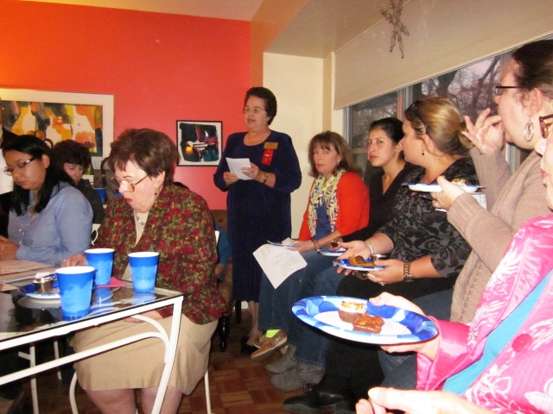
Seen at the January Meeting
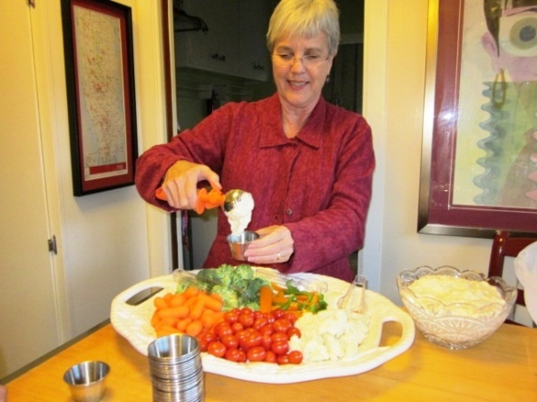

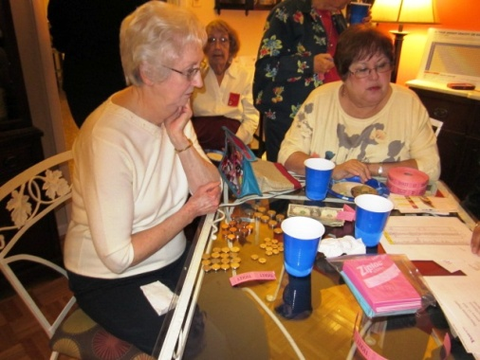

P

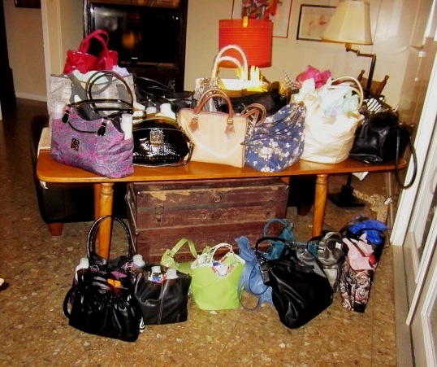
se Purse

33 purses were delivered to the Women's Shelter for
Valentine's Day.
Thank you Shannon and Brenda for leading
this service project!

Project

Purse Project–

Quick Links to our society sites:

International: http://www.dkg.org

State: http://www.alphastatetexas.org/ Be sure to take a look at the information in the committee reports especially the ones in which you have a chapter position.

Theta Gamma Chapter: http://www.orgsites.com/tx/thetagamma/

Have You Changed Your Address/Phone/Email?
If you have changed anything about your address, phone or email -

please notify Carol Walker at 937-3604 or walkerbc64@msn.com
and
Treasurer, Linda Uballe at 537-5762 / 882-6628 or ljuballe@sbcglobal.net

Take the time to find and wear your pin to the next meeting—you’ve earned it.
Members still employed are also encouraged to wear theirs to work on the first Monday of every month. Show our organization off to others – we may pick up a new member that way.

Interested in a Name Badge?

They are available at the State Convention where Iota Omicron sells them. You can also order directly from Annetta Reusch of that chapter.

The badges are $13 unless 10 or more or ordered together. That way they save postage. The check and a note telling her you are a member of Theta Gamma and how you want your name spelled on the badge can be sent to her at 42 Surrey, Iowa Park, TX. 76367. Her email is irislovr@clearwire.net

Make checks payable to Iota Omicron. If you send her an email, she will get it ordered and when your check arrives, she will mail it. It usually takes about a week to week and a half.

Red Roses to these two future DKG members –
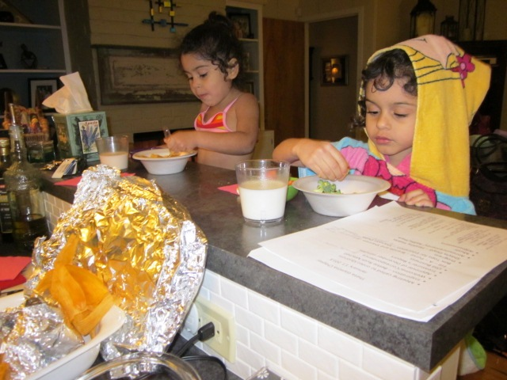

Kim’s girls who were so well behaved during the meeting that some might not have even known
they had returned from swimming lessons and were there.

State Convention

Make plans now to attend (June 20-22) and be a major and very visible part of the 84th Texas State Convention at the Renaissance Hotel in Austin.

