**Theta Gamma Thoughts**

Theta Gamma, Chapter # 195, Area V, Corpus Christi

The Delta Kappa Gamma Society International, Texas State Organization

Volume # 47 Issue # 05 February 2015

Mission Statement: The Delta Kappa Gamma Society International promotes professional and personal growth of women educators and excellence in education.

Leading Women Educators Impacting Education Worldwide

Editor: Carol Walker [walkerbc64@msn.com](mailto:walkerbc64@msn.com)

**President’s Message**

Dear Sisters,

My heart is still overflowing from the abundance of fabrics and pillowcases that were presented at our Annual Chili Supper. First of all, dinner was scrumptious. I am not a chili eater, but for some reason, I look so forward to that meal! Thank you to the retirees who did a great job of making sure we had all the energy we needed to proceed to the next room where our sewing machines awaited us. Everyone hopped in and started working. I have 75 pillowcases to take to the hospital this week. Isn’t that something? I never thought when I mentioned this project that we would take so many pillowcases! I will take pictures to share with you.

My next obstacle was the president’s report. That is where I get to brag about all we do and what we are all about this year. I had the best coaching from Kim and Donna... thank you ladies. I did see some holes in our program that I would like to fill next year with more challenges and ways to not only enrich us, but to help enrich others.

Now we are awaiting our painting night. Thanks to Brandey for organizing this for all of us. By the time you read this, it will have happened. I know it will be a success with not only fun and laughter, but hopefully a few prospective members for us.

Our February meeting will be about looking at our healthy beings. I have a good friend who is my retired school principal coming to talk to us. Lari Ainsworth went to a seminar in Laughing Yoga and is going to come give us a demo of what that means and how it helps stressful everyday lives that many of us experience. She is a wonderful speaker and I am sure everyone will enjoy her tidbits of advice for our healthy hearts!

I hope to see all of you in February. I know everyone is caught up in so many obligations, but I hope you can put Theta Gamma on top that night. It is always so nice to see everyone.

Your president who loves her Sisters,

Shannon

**Next Meeting Information:**

**Thursday, February 19, at 5:15 p.m.**

**Nolan’s Restaurant, on Airline Road**

**Program: The Healthy Heart**

[**Nolan’s on Airline Map Link**](http://www.bing.com/maps/default.aspx?q=Nolan%27s+Restaurant+Corpus+Christi+TX&mkt=en&FORM=HDRSC4)

Also, bring books suitable for the elementary school library in the Philippines named after Neva Gentry’s daughter-in-law.

**Minutes of the**

**January Meeting**

01/22/2015

President Shannon Clubb called the meeting to order at 6:00 p.m. at Calallen Baptist Church. She opened the meeting with a story. In attendance were Shannon Clubb, Debbie VanZandt, Bettie Mitchell, Donna Rodenberg, Norma Janice, Judith Whitlock, Cynthia Besosa, Beverly Tackett, Sylvia Gonzalez, Vilma Zuniga, Sylvia Swift, Luanna Ortiz, Carol Walker, Neva Gentry, Brandey Addison, Sharon Phillips, Kim Brumley, Linda Uballe, and Kay Schroeder. A quorum was present.

An amendment to the minutes pertaining to the absence of Treasurer Linda Uballe at our last meeting was made. Linda’s absence was due to the hospitalization of her mother, not illness on Linda’s part. Minutes were approved as amended.

A condolence card was sent by Luanna Ortiz to Austin area DKG member Bernadine Eaton on the death of her mother Majorie Mendieta.

Linda Uballe gave the treasurer’s report. Our beginning balance was $920.22. Deposits of dues and interest totaled $152.01, and a reimbursement to Kim Brumley for $22.85 left a balance on hand of $1049.38. The report was approved and filed for audit.

Shannon reported on reservations for the State Convention in San Antonio on June 25-27, 2015. She has reserved 1 room for 2 at a cost of $139/night for Thursday-Sunday. She couldn’t reserve a block of rooms without credit cards for the room’s occupants. She is looking for someone with whom to share the room.

Brandey Addison presented information about future programs and service projects. The Crazy Picasso fundraiser will be held on Friday, February 6th, at 7 p.m. at 7602 Staples (Kings Crossing Center). The painting has not yet been chosen. After discussion, it was decided to ask what their most popular, easy painting is and go with that. The goal was moved from recruitment to fundraising for the activity, although inviting potential members is encouraged. We will earn $10 for each person who signs up to paint. There is a 100 person maximum for the space available. Members are encouraged to wear red to the event.

At the last meeting we voted to continue the purse project, but a discussion on purchasing purse items with club funds was tabled during this meeting pending the results of the Crazy Picasso fundraiser.

Debbie VanZandt announced that Teen Bookfest by the Bay needs volunteers to help with the event from 9 a.m. – 4 p.m. on February 28. She had her iPad at the meeting for any members who wanted to sign up. Shannon announced that today the Tuloso-Midway Education Foundation donated $1390 to Teen Bookfest by the Bay to help with author expenses.

The Pride and the Prize Pop Quiz question instructed members to visit the Alpha State website and write down one of the scholarship opportunities for members or their families and the deadline. The winner of a $15 Starbucks gift card was Debbie VanZandt.

The PACE basket raised $19.00. Shannon told the group that one of the PACE areas of donation is the Emergency Fund for members who are victims of natural disaster and read details from a flyer about it.

The meeting was adjourned at 6:45.

The program after the meeting was sewing pillowcases for the children in the Shriner’s Hospital in Houston. Members brought fabric, scissors, thread, and sewing machines to work on these. Seventy-five pillowcases were either brought to the meeting complete or were completed during the sewing portion of the evening.

The next meeting will be February 19 at Nolan’s Restaurant on Airline with a program on The Healthy Heart.

**The Texas State Organization of The Delta Kappa Gamma Society International has a new web address.** It is up and rolling, DKG approved, and you can make the switch easily. Go to <http://www.dkgtexas.org> on your browser address line. Then save it as a favorite.

**At the January Meeting**

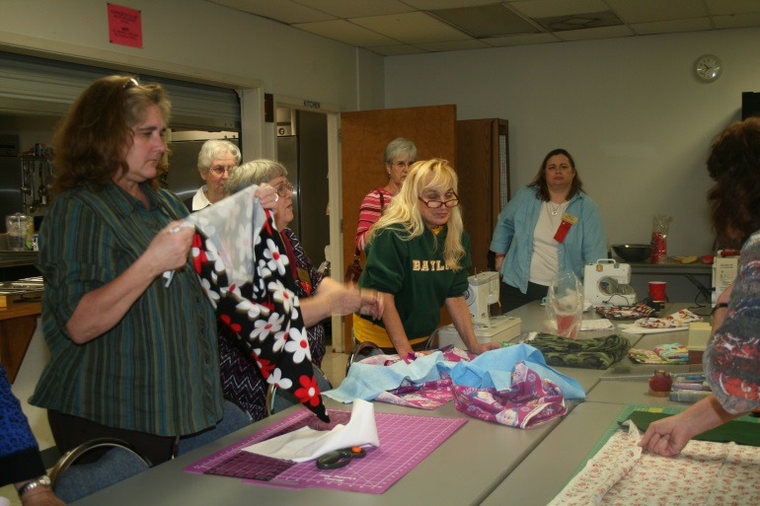

**Photo by Caro**

**74 Pillowcases were made for the kids at the Shriner’s Hospital.**

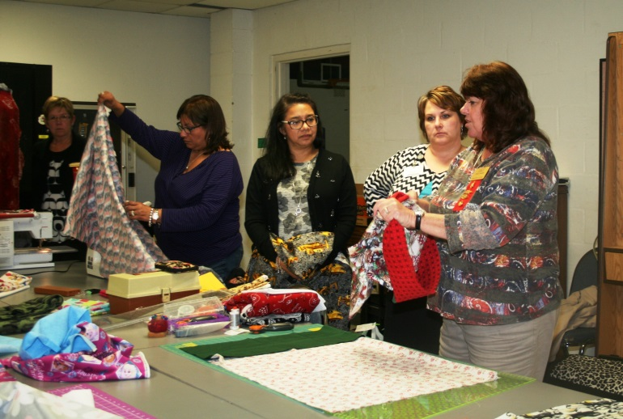

**Photos by Carol**

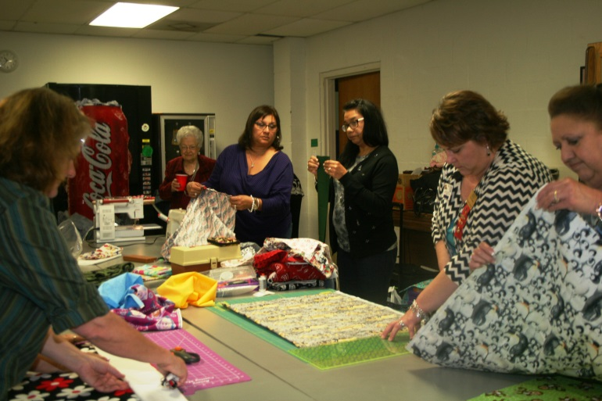



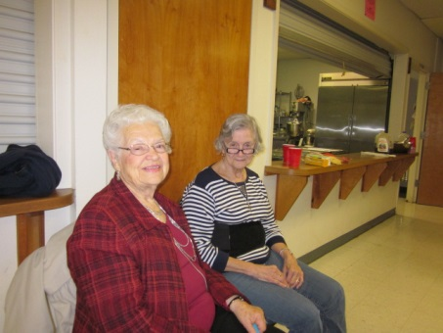

**And…**

Shannon took this one and insisted it be titled – “Supervisors”

**Future Meetings**

**March 7,** 2015 11:00 AM

**Joint Chapters Annual Spring Luncheon** Hosted by Beta Xi

First Baptist Church-3115 Ocean Drive

Guest Speaker-Yolanda Villarreal

Former Calallen School Board Member

Menu

Chicken with Cranberry Sauce

Green Salad

New Potatoes and Peas

Dinner Roll

Banana Split Fruit Dessert

**Cost $17.00 per person**

**Get your check for the luncheon to Treasurer Linda Uballe today if you have not already sent it. Make it out to Theta Gamma**

**April 23,** 2015 5:15 p.m.

Miller High School Library

Program: “Bucket List”

[Miller High School](https://maps.google.com/maps?bav=on.2,or.r_qf.&bvm=bv.74649129,d.b2U,pv.xjs.s.en_US.ZIOukfQmgko.O&biw=1272&bih=600&dpr=1&wrapid=tljp141019811564310&um=1&ie=UTF-8&fb=1&gl=us&sll=27.795214,-97.422646&sspn=0.0291566,0.0439465&cid=2451827330239612031&q=roy+miller+high+school&sa=X&ei=buoNVJ_YOoaL8QGOloGgDw&ved=0CIUBEPwSMAo)

**May 21,** 2015 5:00 p.m.

Sugarbakers Restaurant on Santa Fe

Our recruitment grant scholarship and May Blyth grant to a member will be awarded at our **Founder’s Day/Birthday celebration**.

[Sugarbakers Restaurant Map Link](https://maps.google.com/maps?rlz=1T4ADRA_enUS401US402&q=2766+Sante+Fe+Corpus+Christi,+TX+78404&um=1&ie=UTF-8&sa=X&ei=-ewNVKiIH6Xu8AHE5IGwDw&ved=0CAgQ_AUoAQ)

**Take Pride - Win a Prize**



Congratulations to Debbie Van Zandt for winning a $15 gift card to Starbucks at our last meeting!

What do you know about the Spectacular Texas Art Retreat or STAR?  It includes arts, music, drama, yoga, and dance.  It is an opportunity to relax, create, and make new friends.

Hotel for 2 nights, 6 meals, and all supplies for the weekend all for only $225.00!

Go to [www.DKGTexas](http://www.dkgtexas/) and find out where and when this amazing retreat is located and the dates in **2016!**

Bring your answer to our meeting for a chance to win a fabulous prize!

**Member News**

Gwynetta Hoelscher, Sarah Walker, and Debbie VanZandt are the coaches of the STATE-BOUND Tuloso-Midway Academic Decathlon Team.

The 9-member student team will compete at State in San Antonio Feb. 27 - March t. The topic this year is ***New Alternatives in Energy: Ingenuity and Innovation***. Students are tested in Math, Music, Art, Science, Language and Literature, Social Science, Economics, give a prepared and an impromptu speech, and participate in a personal interview.

**- - - - -**



**Teen Bookfest**

**by the Bay**

**February Update**

As of the writing of this article, Teen Bookfest by the Bay is less than a month away. It’s going to be a super busy week because Academic Decathlon is traveling to the state meet on the same weekend, and I’m leaving for San Antonio immediately after bookfest to be there for the awards ceremony on Sunday morning. All great and exciting things, but I just wish they didn’t all fall on the same weekend. Ah well, que será, será.

Right now, I’m feeling remarkably calm about the whole thing. However, I can’t wait until next month’s update when I’m writing about how it all came out!

**We are still in desperate need of volunteers**. We have fewer than half of the spots filled. Many of them are sitting down jobs (see me for information). Most will allow you to see at least some of the author presentations if you’d like to. If you have some time on Saturday, February 28, I would REALLY appreciate your help!

**Here's how it works in 3 easy steps:**   
1. **Click this link** to go to our invitation page on VolunteerSpot: <http://vols.pt/KSJC8n>   
2. **Enter your email address:** (You will NOT need to register an account on VolunteerSpot)   
3. **Sign up!** Choose your spots - VolunteerSpot will send you an automated confirmation and reminders. Easy!

Note: VolunteerSpot does not share your email address with anyone. If you prefer not to use your email address, please contact me and I can sign you up manually.

Our situation with the venue at Ray High School has changed dramatically since my last report. One of the board members spoke in support of us and the school district agreed to sponsor the fee with the exception of the cost of paying a custodian, reducing the price to $250. We were so thrilled and grateful to CCISD. We also got a $5000 donation from HEB, as well as a $1390 grant from the Tuloso-Midway Education Foundation and found out that the Junior League is donating $1100 in books to be given away.

Our authors are Facebooking and Tweeting about coming to our bookfest. I’m excited to meet them after corresponding by email for almost a year with some of them. A few are already old friends that I’m excited to see again. For book nerds like me, this is like attending a rock concert.

If you’d like more information, please visit our [website](https://sites.google.com/site/teenbookfest/) , or find us on Facebook ([Teen Bookfest by the Bay](https://www.facebook.com/teenbookfestbythebay)) or Twitter ([@TBFBay](https://twitter.com/TBFBay)).

Please remember that [www.smile.amazon.com](http://www.smile.amazon.com) will donate .5% of your purchase amount to Teen Bookfest when you select it as your charity. It doesn’t sound like a lot, but all of the little amounts can add up quickly.

If you have children, grandchildren, nieces or nephews, or neighborhood kids who are in 8th to 12th grades, please let them know about Teen Bookfest, or better yet…bring them!

Debbie VanZandt

**Please Note**

The Texas State Organization of The Delta Kappa Gamma Society International has a new web address.

[**http://www.dkgtexas.org/**](http://www.dkgtexas.org/)

**Alpha State Convention**

[**Click this link to find out why you need to BYOB for the convention.**](http://www.alphastatetexas.org/lonestarnews/2014.winter.pdf)

It is time to begin making plans to attend the 86th Texas State Convention in San Antonio. A good way to begin is by making your hotel reservations right away.

The official convention hotel

is the [Grand Hyatt](https://aws.passkey.com/g/25186170) on the River Walk.

[Convention Website](http://86thtsoconvention.weebly.com/)

[**Resources for Learning About Empathy on Valentine's Day**](http://r20.rs6.net/tn.jsp?f=001pMFBeuAuiM4JBjlN__4vNzumo9j_h2zDROn8SvZXNIAaULQVYsQTVqYqebwPPLbJSpGWECQ7pRhFuAnUdxMLgZdDaZlHQMYc1QiqS5A0nko_bY4xKSg5o-sPAMQd-0rcX_Z2P_RIq3v1YsTBMxPsklcmhK0oyc_INY6Lw4pKuAoR22pNCkTfv44nF5vJBQtQ1bQUEXubIMasyqw7I1WgxNT5nwSaAjs_NIxInjsm68XOsD_sFt32lPxw63wHXW-d140uZXV3Qb_-rkHdC565iBpZ2_NYhBjXyR_lrt4lJKeIzHDA9SBAq_yJyXUWh3QIhuBpMMDRyk1IyqQm-a9whRgJcMOyxmDaDzfrPfk493EBXuLPux37Og==&c=2MEZJKf8sVaur7Tyt5F_-wpieHhoSiExb45FR3TttersvBl7Elg6kg==&ch=CpFhJuQZXu5VaZQBleHqeeDfalKx798JVRncSBjGFTL2HV-dIy3OAw==)

(the above is a hyperlink)

From the “Before **the Bell E-Newsletter”**

**These lesson plans, tips, and toolkits can be used throughout the year**

**Any change in your contact information?**

If so, please notify Carol Walker @ 937-3604 or [walkerbc64@msn.com](mailto:walkerbc64@msn.com)

Microsoft Word clip art

**Think Scholarships NOW!**

Our Esther Jane Roark Hahn Memorial Recruitment Grant is awarded to a resident of the Coastal Bend pursuing a career in the field of education. The grant is for $300.00 and may be used for tuition, registration fees, books or supplies. The applicant may be enrolled in any

level of education with the transcript reflecting an overall average of at least 2.0. Preference is given to relatives of Theta Gamma members.

Do you have a student or a family member that meets these qualifications? If so, please remember the application is due to the Scholarship Committee **before April 1**.

As a member of Theta Gamma you are eligible to apply for the May Blythe Theta Gamma Scholarship. You must have been a member of Theta Gamma for at least one year. The scholarship is for $300.00 and may be used for tuition, fees, books or supplies at a non-society continuing professional education event, seminar, workshop, or graduate class.

Remember the scholarship does not have to be used for a formal classroom setting course. Some of you may be passing up free money. The application is due to the Scholarship Committee before April 1.

**Applications are in your yearbook and also attached to the email in which you received this newsletter.** Please open and print out the application you need. Fill it out and bring it to the next meeting, email, or mail it to our scholarship chairman:

Mrs. Bettie Ruth Mitchell,

4729 Sea Island Drive 78413

[**betmitchell@yahoo.com**](mailto:betmitchell@yahoo.com)

