Theta Gamma Thoughts
Theta Ga.m.ma, Chapter # 195, Area V, Corpus Christi
The Delta Kappa Ga.m.ma Society International, Texas State Organization
Volume # 46 Issue # 01 September 2013
Mission Statement: The Delta Kappa Ga.m.ma Society International promotes professional and personal growth of women educators and excellence in education.
Editor: Carol Walker walkerbc64@msn.com

President’s Message
Hello Sisters!

During our short summer, I have run into several sisters in our chapter and they’ve asked when we will be having our first meeting! I can happily say, our first meeting is Thursday, September 19, 5-7p.m. @ Dos Comales.
I started to think about why I’m a member of DKG. There are so many reasons to belong to this international society for key women educators, I thought would name just a few:

- Genuine friendship and collegiality with a network of educators
- Grants and stipends for research and special projects
- Leadership training and professional development through conventions, conferences, workshops, and seminars
- Opportunities to make presentations at meetings, workshops and conferences and to write for juried publications
- Participation in service projects to help organizations in need
- Program. presentations that enrich our lives

It is an honor to be a member of DKG. Think about why you are a member of this organization. Is there someone you would like to recommend for membership that can benefit from the many opportunities available through DKG? Think about someone that is currently employed as a professional educator, or a self-employed educator, such as a private music teacher, or retired from an educator position.
Bring the attached recommendation for membership form to our first meeting in September so that we may invite them to become a member!

See you in September!
Donna

Next Meeting Information:

Thursday, September 19, 5:00 p.m.
at Dos Comales Restaurant
227 N Water St
Linda Uballe will be accepting your dues payment in the amount of $76.00. If payment is made at the September meeting, you will receive a free ticket for the basket drawing.

Minutes – May Meeting
Minutes of Regular Meeting
May 16, 2013
The regular meeting was called to order at 5:30p.m. by President Donna Rodenberg, the secretary Angela Steagall being present, at Nolan’s Restaurant on Airline.

Due to a pressing scheduling conflict the Ester Jane Hahn Scholarship recipient, William Steagall, was presented with his scholarship by committee member Norma Janice. He was very pleased and thankful.

After an inspirational reading by Kimberley Brumley about the leadership of women, we went on to have the business meeting.

Minutes from the last meeting were approved as read with no corrections. The treasurer Linda Uballe reported the current balance on hand is $544.75 as of May.

The Scholarship Committee recognized our other two scholarship recipients. Amanda Van Zandt, who was at her last choir concert, sent a card of thanks which was read by Kim Picozzi. She was very excited about being awarded an Esther Jane Hahn Scholarship. Our other scholarship for continuing education was presented to Kimberley Brumley by Elnora Corbin. It was a great evening of celebration for these recipients.

Nancy Shaheen shared that she is moving to the Hill Country. We will miss her.

The program for Founder’s Day was a great success, and featured the many hats that women wear, especially in education.

Janice Doughty won the scholarship Basket of gift cards and that raffle brought in $96.00. The PACE collection was $9.66.

The president adjourned the meeting and we dismissed in song.
We celebrated with birthday cake and our birthday song.
Angela Steagall
Recording Secretary
State Convention:

The 84th TSO Convention was held in Austin at the Renaissance Hotel, June 20-22, 2013. Donna, Kim, Norma, and Carol experienced the “capital” convention and had a good visit with former Theta Gamma president, Sandi Morales.
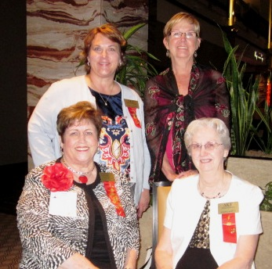

Kim, Donna,
Norma and
JoAnn Brooks, past Texas State President

Sandi, Carol, and Norma took advantage of a “photo op” at the ice cream social the night before the convention opened.

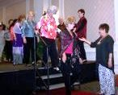

Donna in The Parade of Presidents during the Belles and a Beau evening.

Congratulations
to our sister Roxanna Guerrero, who was hooded May 16 and graduated with her master's. She's an honor graduate and is pictured here with colleagues Jeff Fox, Cristina Leal, Sukhbir Singh, and Christian Auger. DKG sister Kimberly Craig snapped the photo.

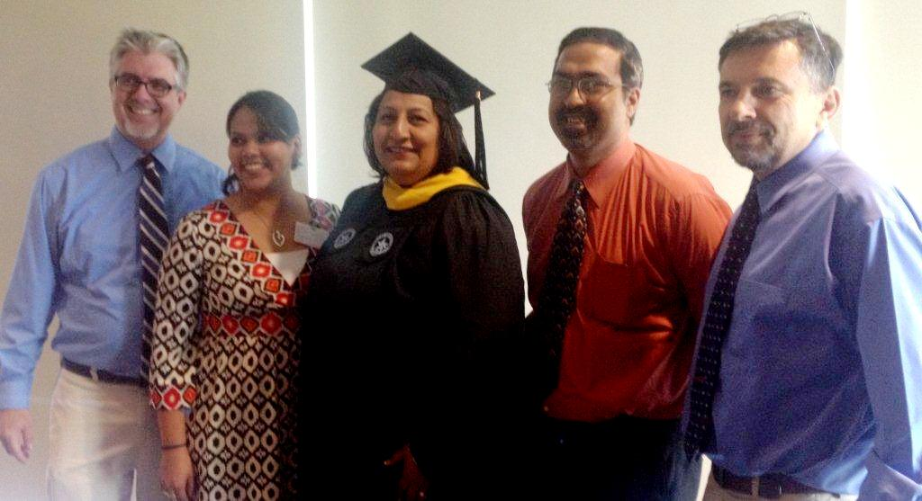
and to our chapter because

Theta Gamma was honored with the Annie Award for our outstanding program "Fill-a-Purse, A Gift of Love"

Theta Gamma was presented with the Presidential Award for Chapter Excellence. This is in recognition of outstanding performance in all facets of Delta Kappa Gamma work.
Future Meetings

October 24, 2013
5:15 p.m. at Jason’s Deli on Airline Orientation for Prospective Initiates

November 9, 2013
10:00 a.m. Initiation at Trinity Towers

December 12. 2013
5:15 p.m. at the home of Angela Steagall 561 Parade Dr. 78412 991-3649
Scholarship fundraising via a holiday Items raffle.

January 23, 2014
5:15 p.m. Annual Chili Supper at St. Paul the Apostle Church, 2233 Waldron
“Die for Scholarships:” Enjoy a social night of scholarship fundraising by playing Bunco.

February 20, 2014
5:15 p.m. Del Mar College Room 514

March 22, 2014
11:30 a.m. Joint Chapters Luncheon – Our responsibility this year still TBA

April 24, 2014
5:15 p.m. In the Library at TM Middle School
Shannon Club will speak of her experience mentoring teachers in an African village.

May 22, 2014
5:15 p.m. at the home of Kay Schroeder 15357 Bowsprit Ct. on the Island
Our recruitment grant scholarship and May Blyth grant to a member pursuing further studies will be awarded at our Founder’s Day/Birthday celebration. The new slate of officers will be approved and installed.

Quick Links to society sites:

International: http://www.dkg.org

State: http://www.alphastatetexas.org/ Be sure to take a look at the information in the committee reports especially the ones in which you have a chapter position.

Theta Gamma Chapter: http://www.orgsites.com/tx/thetaga.m.ma/

Have You Changed Your Address/Phone/Email?
If so please notify Carol Walker at 937-3604 or walkerbc64@msn.com
and
Treasurer, Linda Uballe at 537-5762 / 882-6628 or ljuballe@sbcglobal.net

Take the time to find and wear your pin to the next meeting—you’ve earned it.
Members still employed are also encouraged to wear their pins to work on the first Monday of every month. Show our organization off to others – we may pick up a new member that way.

Want a Name Badge?
You can order directly from Annetta Reusch of Iota Omicron.

The badges are $13 unless 10 or more or ordered together. That way they save postage. The check and a note telling her you are a member of Theta Ga.m.ma and how you want your name spelled on the badge can be sent to her at 42 Surrey, Iowa Park, TX. 76367. Her email is irislovr@clearwire.net

Make checks payable to Iota Omicron. If you send her an email, she will get it ordered and when your check arrives, she will mail it. It usually takes about a week to week and a half.

