The Delta Kappa Gamma Society International
Leading Women Educators Impacting Education Worldwide
Theta Gamma Thoughts
Alpha State Texas Corpus Christi, Texas
Area V
Volume 45 Theta Gamma
Number 02 Chapter # 195
October 2012
Editor: Carol Walker walkerbc64@msn.com

The Delta Kappa Gamma Society International promotes professional and personal growth of women educators and excellence in education.

Dear Theta Gamma Sisters,

Lighting the Way to Chapter Success
Sisterhood: a bond between two or more women, not always related by blood.
They honor each other and love each other like sisters.
On October 18 we will welcome four prospective sisters to our chapter. This meeting will showcase our Society purposes as we begin to form and develop relationships with these new members.
As your fellow sister and president, my goal is to ensure our chapter is forward thinking and benefits you and our community. The September meeting was packed with visionary ideas and shared collaboration that will enable us to explore the many possibilities of the upcoming year. This will be further enhanced by our four new sisters joining us in this bond of sisterhood.
In preparing to meet our new sisters – something to consider:
“We have three innate psychological needs: competence, autonomy and relatedness. When those needs are satisfied, we’re motivated, productive, and happy. When they’re thwarted, our motivation, productivity and happiness plummet.” - Daniel H. Pink in Drive, The Surprising Truth About What Motivates Us
Let’s welcome our new sisters and let them know we honor and value their membership in a most successful chapter!
See you in just a few days,
Donna

Next Meeting Information:

October 18, 2012
5:15 PM
Del Mar College room 514 (east/main campus Library) Map to the Del Mar Library

Orientation for Prospective Initiates

This meeting will light the way for prospective initiates to learn about the history and benefits of our Society at the local, state, and international levels via a Power Point presentation, interactive groups and Smart Board technology.

PACE monies will go to the Eula Lee Carter Memorial Fund

Pay your dues ($76 – check made to Theta Gamma) at the meeting
or send them before the meeting to treasurer Linda Uballe, at 3102 Santa Fe # 4C, 78404
Her deadline to state is that same week.

Minutes of the September Meeting

Theta Gamma Chapter
Minutes of Regular Meeting
September 20, 2012

The regular meeting was called to order at 5:35 pm by President Donna Rodenberg. An inspirational reading was given by Beverly Tackett. The minutes of the last meeting were approved as read with no corrections. There was no correspondence since the last meeting.

The treasurer, Linda Uballe, reported a balance as of August 30, 2012 of $971.46. After expenses from the State Convention, the current balance is $372.15. Norma Janice presented the yearly budget and it was unanimously approved.

Margaret DeVille proposed honoring a sister that we lost in the spring, Theo Wagner. Theo cared for her family, retired teachers, Delta Kappa Gamma and teaching for Tuloso-Midway ISD. Margaret asked that the chapter consider making a donation to the TM Education Foundation in memory of Theo Wagner. Monies can be sent to Sharon Trott or Margaret DeVille. There was discussion on an appropriate remembrance and if the chapter should donate or if we should leave it to individual members to donate.

Brandey Addison came forward to discuss making a more clearly defined Rule 10C in our Theta Gamma Chapter Rules which concerns voting for membership. She asked that the wording be changed from unanimous vote to majority vote by secret ballot. It was motioned and seconded to make that change and all sisters were in agreement.

The names and profiles of four new members were brought forward by Donna Rodenberg. Sharon Phillips, Roxanna Guererro, Kimberly Craig and Christy Solis were all proposed for membership and accepted unanimously by secret ballot.

Corresponding Secretary Debbie Van Zandt passed two cards around for signatures to be sent to Joan Short and Carol Walker.

The PACE collection was announced with a total of $21.00 and the monthly scholarship raffle earned $91.00.

Everyone broke into committees to discuss their plans for the year. After meeting in groups, the Finance Committee decided that the chapter would not make a donation to the TMEF on behalf of Theo Wagner, but the committee encouraged individual giving.

The scholarship raffle basket drawing was held and Kim Brumley was the winner.
The president adjourned the meeting at 7:00 pm and we dismissed in song.

Angela Steagall
Recording Secretary

Future Meetings

November 3 Joint Chapters Initiation 10:00 AM First Baptist Church on Ocean Drive

December 6th, Fellowship and Fundraising through Bunco
at the home of Brandey Addison, 3833 Julia Lane, 78414

January 17^{th,} Annual Chili Supper at Kim and Donna’s Home

February 21st, Professional Affairs and Legislation at the TAMU Alumni Association
Leroy DeHaven, TRTA District Presidents Council Vice-Chairman, and
Nancy Benson, President of the Corpus Christi Retired Teachers Assn.

March 9th – Joint Chapters’ Luncheon at Trinity Towers, 101 Upper North Broadway

April 18th, in the Computer Lab at TM Intermediate School for “Printerest”

May16th, Founders Day and Chapter Birthday at Chef Mark’s at Six Points

State Scholarships

The Texas Organization of The Delta Kappa Gamma Society International has several generous scholarships available to its members. There are scholarships available for graduate studies, continuing adult education, and educational travel. Scholarship information, instructions, and application forms may be printed from the links on this page.

The following documents are Adobe Acrobat PDF versions. The applications are interactive and savable. To download the most recent version of Adobe Reader, please click the Adobe Reader link.
2012 Scholarships and Grants Awarded
2012 Scholarships Contributions Recognition
Familiar faces and names as seen in the
Corpus Christi Caller-Times

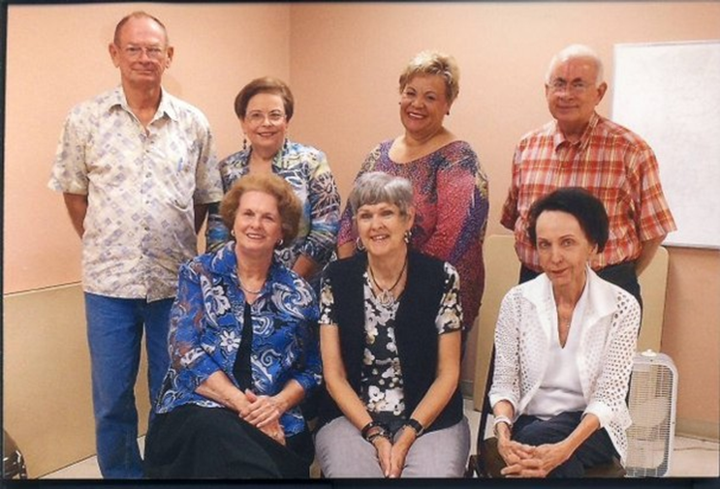

October 5, 2012

The new officers for the 2012-13 Corpus Christi Area Retired Teachers Association includes Leroy DeHaven (back row, left), immediate past president; Margaret DeVille, recording secretary; Betsy Chapman, treasurer; Anson Nash, second vice president in charge or programs; Patricia Stewart (front row, left), corresponding secretary; Nancy Benson, president; Dottie Pittman, in charge of membership.

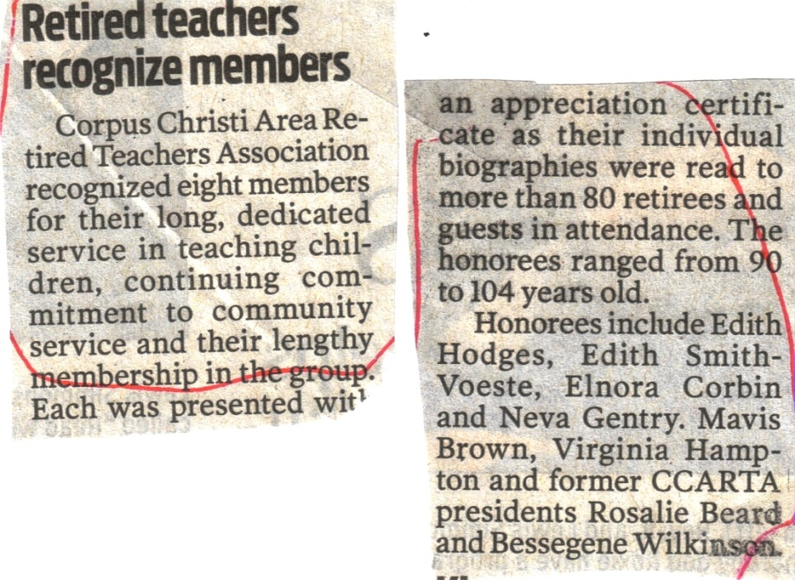

Editor’s note: Since the Caller-Times did not see fit to put this article on their website, you will have to settle for this which I cut out of the October 5th edition.
Note the names of our two sisters who were honored.

Quick Links to our society sites:

International: http://www.dkg.org

State: http://www.alphastatetexas.org/ Be sure to take a look at the information in the committee reports especially the ones in which you have a chapter position.

Theta Gamma Chapter: http://www.orgsites.com/tx/thetagamma/

Have You Changed Your Address/Phone/Email?
If you have changed anything about your address, phone or email -

please notify Carol Walker at 937-3604 or walkerbc64@msn.com
and
Treasurer, Linda Uballe at 537-5762 / 882-6628 or ljuballe@sbcglobal.net

Take the time to find and wear your pin to the next meeting—you’ve earned it.
Members still employed are also encouraged to wear theirs to work on the first Monday of every month. Show our organization off to others – we may pick up a new member that way.

Interested in a Name Badge?

They are available at the State Convention where Iota Omicron sells them. You can also order directly from Annetta Reusch of that chapter.

The badges are $13 unless 10 or more or ordered together. That way they save postage. The check and a note telling her you are a member of Theta Gamma and how you want your name spelled on the badge can be sent to her at 42 Surrey, Iowa Park, TX. 76367. Her email is irislovr@clearwire.net

Make checks payable to Iota Omicron. If you send her an email, she will get it ordered and when your check arrives, she will mail it. It usually takes about a week to week and a half.

