Theta Gamma Thoughts
Theta Ga.m.ma, Chapter # 195, Area V, Corpus Christi
The Delta Kappa Ga.m.ma Society International, Texas State Organization
Volume # 46 Issue # 03 November 2013
Mission Statement: The Delta Kappa Ga.m.ma Society International promotes professional and personal growth of women educators and excellence in education.
Editor: Carol Walker walkerbc64@msn.com

President’s Message

Happy Holidays!
My son, Christopher recently told me he was “unplugging” from social media for a while. He is training for a marathon. I was proud and it made me think about things I should make time for. This is a time of year we make lists, so here is what I listed.

- Enjoy coffee, tea or any beverage outside and listen to the birds.
- Write a letter to someone you miss.
- Enjoy nature and notice the little things.
- Clean/organize your closet/donate clothes and blankets.
- Notice people and smile.
- Read a book, touch it, and make notes in the margin.
- Contact someone you miss and have lunch.
- Prepare a special meal for no reason.
- Visit a museum.
Make # 10 the beginning of your list.

Enjoy your list!
See you in December,
Donna
Next Meeting Information:

December 12 5:15 p.m.
at the home of Angela Steagall
561 Parade Dr. 78412 991-3649
Scholarship fundraising via a holiday Items raffle. Bring something everyone will like - something you would like to keep for yourself! It can be a Christmas or seasonal item or anything else that our ladies will want to have for themselves or for a gift. It can be edible. It can be readable. It can be wearable. It can be growing. It can be a product of your creative expertise or hobby. It can be decorative. Start now to shop for your item or start making it or plan to bake it just before the meeting
Minutes – October Meeting
Theta Gamma Chapter of Delta Kappa Gamma
Meeting Minutes of 10/24/2013
The meeting was called to order at 5:30 p.m. by President Donna Rodenberg at Jason’s Deli on Airline. A quorum was present.
The inspiration was given by Libby McGee. She presented her “10 to Zen” list (which will be emailed to members). She explained that she keeps the list near her computer and goes through it each morning taking a deep breath in and out between each item.
The September minutes were approved as published in the newsletter.
Linda Uballe gave the treasurer’s report. The opening balance was $413.84 with deposits amounting to $1702.01, and no disbursements. Balance on hand as of 10/24/2013 is $2115.85. The report was approved and filed for audit.
The Personal Growth and Service committee reported that the Women’s Shelter appreciated the donation of purses and necessary items, and requested discussion about whether the project should continue this year. In discussion, a suggestion was made to replace the phone card with a store gift card (HEB, Target, Wal-Mart, etc.) in the amount of $10. A question was raised about timing the project to coincide with either Valentines or Easter. A recommendation to continue the project for Valentines was made and seconded. The vote was unanimous in favor of continuing the project. Each donation will consist of a purse, full-size shampoo/conditioner, body wash, toothbrush, toothpaste, snacks, and a 1 week bus pass.
A second opportunity for service was suggested. The Corpus Christi Food Bank is in need of volunteers to help stack, stock, and distribute food items. Groups might commit to work a 4-hour shift each month. No vote was taken on this item.
The program for the evening, entitled Superheroes was presented by Libby McGee, Christi Solis, Laura Day Brown, and Brandey Addison. They introduced 3 types of thinking maps to show us what we know and how we think about superheroes. The last map compared and contrasted DKG members with Wonder Woman, and we discovered that we have much more in common than we would have thought.
Announcements were made as follows:
1. Libby asked members to volunteer to judge at the TM Intermediate Science Fair on November 14th.
2. There was no correspondence this month.
3. The next meeting will be held November 9 at Trinity Towers. Elnora will be honored and Sharon Phillips will be initiated at this meeting.
4. The Raffle basket raised $64 and was won by Carol Walker.
5. The PACE collection was $13.
Rather than singing the Delta Kappa Gamma song, Kim Brumley presented a “Mad Libs” version that was created by Kimberly Craig. Suggestions of nouns, verbs, adjectives, and adverbs filled in the blanks, and Kim sang the final product to much laughter.
Meeting was adjourned at 6:40 p.m..
Submitted by Debbie VanZandt, Corresponding Secretary for Angela Steagall, Recording Secretary

“A teacher affects eternity; she never knows where her influence will end."- John Adams 1907

2013-14 Project Update
Fill-A-Purse
At our last meeting we voted on making the Fill-A-Purse Project our main project for this year. This project was well received last year, and we know it will be just as successful this year with everyone's help. We need 35 purses, so this means that everyone needs to participate for us to meet that number.
The completed purses and supplies are due by February 1st (Saturday) to be taken over to the Women's Shelter for Valentines' Day. If you complete your purse before that date, just bring them to our December, or January meeting.
If you are unable to attend one of those meetings, call Shannon Clubb (361-387-5740) or Brenda Machen (361-537-2322) for pick-up, or drop them off at Donna Rodenberg's home, 3309 Casa Bonita, CC 78411. Call first to be sure she is home - 361-215-5127.
Thank you for your interest and desire to assist those in our community that need a helping hand.
Theta Gamma Sister,
Brenda Machen
Member News
James and Brandey Addison are excited to announce that they are expecting a new addition to their family in May 2014.
Judith Whitlock’s son and daughter-in-law are now stationed in Seoul, South Korea. Her husband, Tommy, will have knee replacement surgery on December 3. Their oldest son and daughter-in-law will arrive on Sunday before the surgery and stay for two weeks.
Angela Steagall and Debbie Van Zandt both presented at the TCEA conference at ESC2 November 5th. Angela presented "Texas TECH: How Texans Integrate Technology into Student Activities", and Debbie presented "What! Google is more than a search engine!"
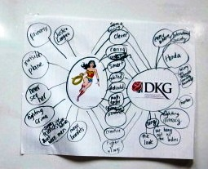
The conference gave over 300 attendees the opportunity to network and learn the best practices from their peers, and to acquire resources to assist them with advance learning through technology.
Silvia Swift and her grandsons did a presentation and display on Native American Traditions, Culture Yesterday and Today for the CCISD Native American Studies Program and the Carroll H. S. Culture Club on November 14th
The Last Meeting
Needless to say, since we were at Jason’s Deli, the food was excellent and so was the program.
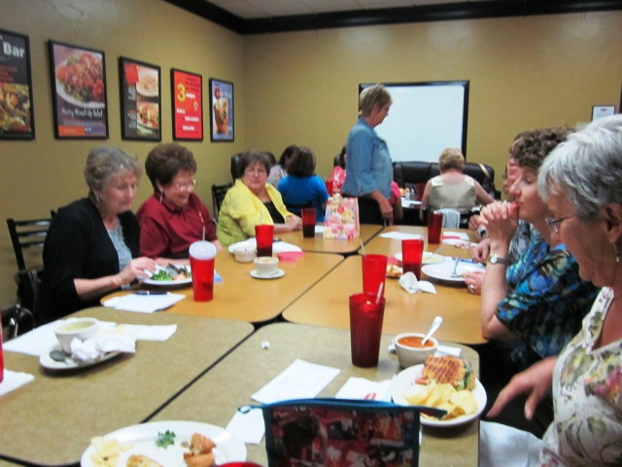
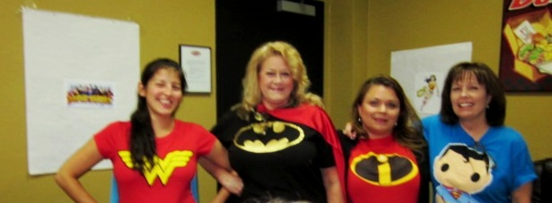
Since we had no new members to orientate (but we do have a few reinstating ones) Brandey and her “Super Cohorts” came up with something different.
They led us in brainstorming using a Thinking Map* for Superheroes to find their common good qualities leading to another one specifically for Wonder Woman, and then to the last one that showed the similarities and differences between Wonder Woman and a DKG Woman.
Everyone was involved and interested throughout the activity.

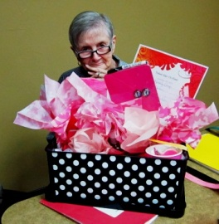
I was lucky to have the winning raffle ticket for the beautiful Breast Cancer themed basket that was so appropriate for the month of October. The basket was put together by Kimberly Craig and her committee.

Future Meetings
January 23, 2014
5:15 p.m. Annual Chili Supper at St. Paul the Apostle Church, 2233 Waldron
“Die for Scholarships:” Enjoy a social night of scholarship fundraising by playing Bunco.

February 20, 2014
5:15 p.m. Del Mar College Room 514
“The Magnificent 7” (women) principals in CCISD will be our guests and will participate in a panel discussion.

March 22, 2014
11:30 a.m. Joint Chapters Luncheon – Our responsibility this year at Corpus Christi Country Club

April 24, 2014
5:15 p.m. In the Library at TM Middle School
Shannon Club will speak of her experience mentoring teachers in an African village.

May 22, 2014
5:15 p.m. at the home of Kay Schroeder 15357 Bowsprit Ct. on the Island
Our recruitment grant scholarship and May Blyth grant to a member pursuing further studies will be awarded at our Founder’s Day/Birthday celebration. The new slate of officers will be approved and installed.

Changed Your Address/Phone/Email?
If so please notify Carol Walker at 937-3604 or walkerbc64@msn.com
and
Treasurer, Linda Uballe at 537-5762 / 882-6628 or ljuballe@sbcglobal.net

Initiation
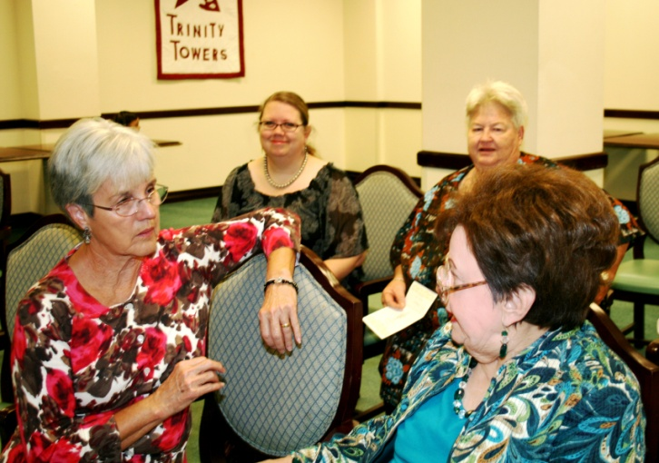
Visiting before the ceremony: Beverly, Angela, Janice, and Margaret

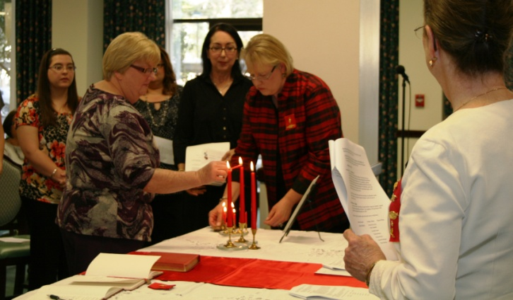

Sharon Phillips lit her candle before signing the register and then received her rose from Donna with Kim, her sponsor, behind her.

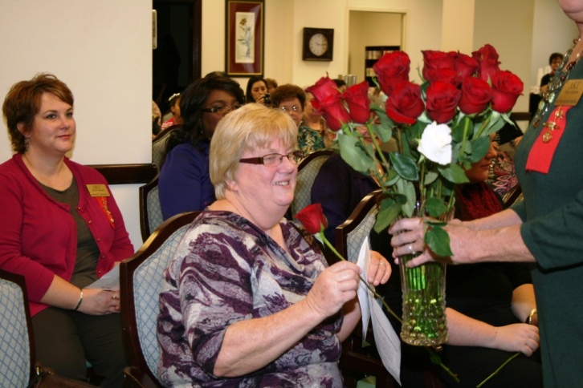

Neva Gentry receives the white rose of remembrance after giving Elnora Corbin’s eulogy.

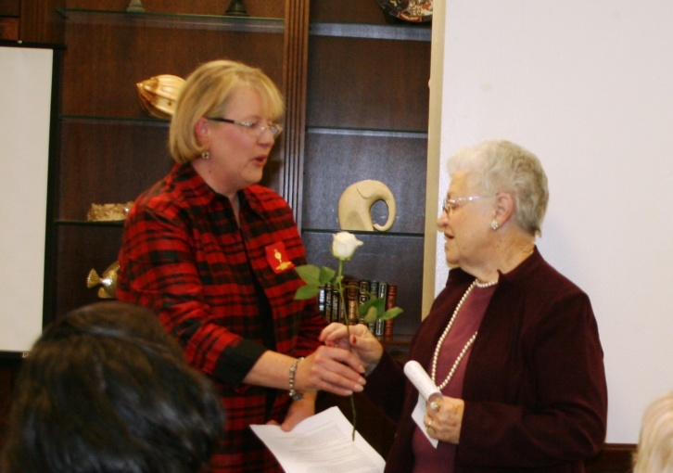

Quick Links to society sites:

International: http://www.dkg.org

State: http://www.alphastatetexas.org/

The digital-only Fall 2013 Lone Star News is available here and on the Publications page

Theta Gamma Chapter: http://www.orgsites.com/tx/thetaga.m.ma/

Take the time to find and wear your pin to the next meeting—you’ve earned it.
Members still employed are also encouraged to wear their pins to work on the first Monday of every month. Show our organization off to others – we may pick up a new member that way.

Make a firm commitment
to Delta Kappa Gamma:
True to “the calling,” as we “firmly rally” because “our sisters need us,” and because our pledge is that “Education e’er we’ll further!”
A commitment to Delta Kappa Gamma is a personal commitment to learning, to enjoyment, to friendship, to our lifetime service to education. - Mary Nabers – Nu Chapter

Check Out Our
Alpha State Website
For…

New ASTEF/Road Scholar Travel Adventure
Colonial and Revolutionary Virginia: Jamestown, Williamsburg, Yorktown - Embark on a journey through Virginia's "Historic Triangle" with no less than a dozen historians and other experts. Flyer

The digital-only Fall 2013 Lone Star News is available here and on the Publications page.

Additionally, we present for your convenience and enjoyment, an interactive version of the Lone Star News. (To page through the interactive version, click and drag the upper right corner.)

If a doctor, lawyer, or dentist had forty people in his office at the same time, all of whom had different needs, and some of whom, didn’t want to be therer and were causing trouble, and the doctor, lawyer, or dentist, without assistance, had to treat them all with professional excelence for nine months, then he might have some conception of the classroom teacher’s job. - Donald D. Quinn

